**Unit 4.1 The role of marketing**

Know that marketing often relies on the support of finance and operations departments in order to develop marketing strategies that are financially viable and operationally possible. Be able to comprehend the meaning of this information. E.g. when setting the price using a cost-plus method, the data essential to determine this price, as well as the preferable target mark-up and profit, will be provided from other departments.

**Syllabus Objectives**



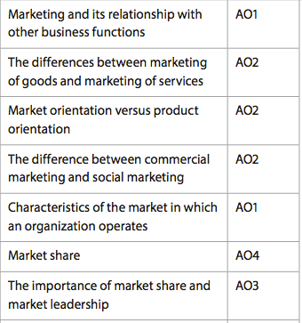

Know that marketing of goods requires the ‘4 Ps’, product, price, place and promotion, whereas services have 3 additional Ps, people, processes and physical environment. Be able to break concepts down into individual characteristics and see the broader picture how they relate. E.g. The physical environment of a nail salon and the person who manicured your hands helps create a brand for the organization, whereas the bottling factory and assembly line worker at Coca-Cola have no influence on the their branding

Know that some business focus on product first, customers later and some consider customers first, product later when investigating marketing plans. Really it is a combination of the two. Be able to break concepts down into individual characteristics and see the broader picture how they relate. E.g. Product orientated firms like Google are developing robot driven cars and Google Glass despite their being no highly desirable need for these products from the market. However, product development helps lead innovation and new advancements in technology

Know that businesses will often develop marketing plans that have different objectives and methods to social marketing campaigns. Be able to break concepts down into individual characteristics and see the broader picture how they relate. E.g. Cost is often a leading determinant in whether a business uses ATL promotion, placing and product strategies, however, social marketing campaigns are often able to overcome resource issues to innovatively promote social awareness and other campaigns using technology

Know that markets can be defined by market size, market growth and market share, and a business can occupy a position somewhere based on these themes. Be able to comprehend the meaning of this information. E.g. A business may operate in a large market with a small market share, however this may be more favourable than in a small market with a high market share.



Know that the size of a market may be derived by its revenue or its unit levels of output. Be able to calculate market share. E.g. A business with sales revenue of $1m in a market that has revenue of $100m has a market share of 1%.

Know that market leaders are able to benefit from many advantages over smaller or less established rivals, such as greater economies of scale, and the ability to introduce new products under a brand name. Be able to combine and synthesize these ideas into a new idea and make a judgment based on the weight of evidence. E.g. Apple enjoys the benefit of introducing new iPads at frequent intervals even though the current version of the iPad remains a highly functional piece of technology. Regardless of the new features, many Apple user will connect the success of the organization to the quality of its newest product, a luxury new entrants in the tablet market could only dream of.



Know that for-profit marketing objectives often include increasing sales revenue, market share etc, whereas non-profits usually focus on raising awareness of an issue and raising donations. Be able to combine and synthesize these ideas into a new idea and make a judgment based on the weight of evidence. E.g. non-profits are more likely to have socially-minded objectives, and their marketing objectives may be to raise awareness. However, it can be expensive to promote awareness using mass media technologies such as TV.



Know that change is constant in the lives of marketers. The largest driver for change is the changing nature of customers due to newfound wealth, change is demographics and the advancement of technology and greater access to worldwide products. Be able to combine and synthesize these ideas into a new idea and make a judgment based on the weight of evidence. E.g. As consumers begin to consider the ethical implications of their actions, such as the impact on animals that cosmetics testing has, companies have needed to change their product development systems to meet this change in expectation.

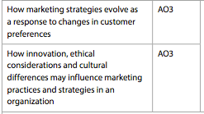

Know that the highlighted concepts may influence the product, the promotions, the price or the places sold of a variety of branded products. Be able to combine and synthesize these ideas into a new idea and make a judgment based on the weight of evidence. E.g. the tobacco industry has been significantly hindered by changes in the ethical considerations of customers, parents, health groups etc. This has led to almost complete abolishment of tobacco promotion, reduced places for sale, ‘healthier’ changes to the product etc.

**Example questions may include:**

Define the term *product orientation*  [2 marks]

Calculate Market share [2 marks]

Explain the difference between social marketing and commercial marketing [4 marks]

Analyse two benefits of a for-profit business using a social orientation in

its marketing [6 marks]

Discuss whether market leadership is developed by having a strong product or

a strong brand [10 marks]