FCM Customer Base 10

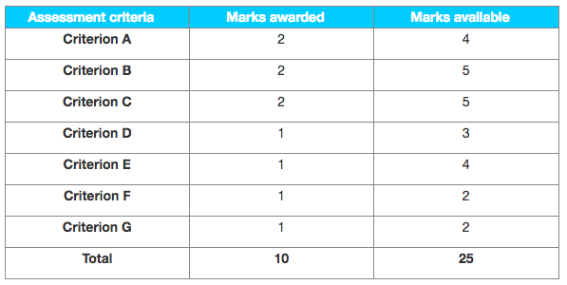

Examiner comments

**This SL IA is too short (1200 words), there was potential to develop the ideas more and to score much higher (for example for D and E).**

**Criterion A – Supporting documents**

The introduction (page 3) claims three supporting documents however only two of these seem included at the end of the SL IA. Where there are actually some others, including some irrelevant materials: the first one (page 9) is a SWOT written by the student that cannot be accepted as a supporting document (but it is also copied in its entirety in the main body page 4); the second one (pages 9–10) just consists of logos, which is confusing; it seems however that the appendices numbered 5 and 6 (page 13) constitute two other supporting documents (though this is not fully clear) so in total there are three to five relevant supporting documents.

**Criterion B – Choice and application of tools, techniques and theories**

Limited and superficial choice and application of tools, techniques and theories—mainly the use of subject terminology: promotion, segmentation, etc.

**Criterion C – Use and analysis of data and integration of ideas**

Little in the supporting document is relevant for the research question and is being used (this is also due to the limited quality of the supporting document).

**Criterion D – Conclusions**

There is a very short conclusion page 7 (two sentences), however it is not clear how it links to the main body of the SL IA.

**Criterion E – Evaluation**

Limited evidence of evaluation.

**Criterion F – Structure**

Not easy to follow.

**Criterion G – Presentation**

Some efforts, for example in terms of referencing with the footnotes, however other aspects of presentation are too weak (for example the appendices and supporting documents).