**Unit 1.7 Organisational Planning Tools HL Only**

**Syllabus Objectives**



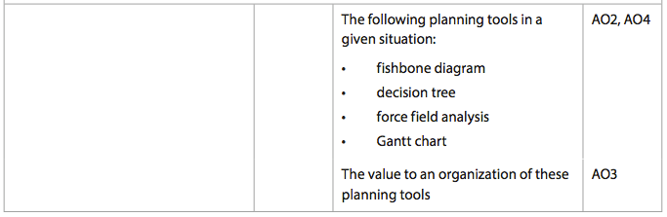

Know how to construct each of these planning tools fully labeled. Know the advantages and limitations of each model. Be able to break concepts down into individual characteristics and see the broader picture how they relate. E.g. a decision tree is a great tool to make a financial decision, however it is based on predicted data and probabilities so may be influenced by the bias of who provided the information.

Know the purpose of each of these tools overall to an organization, as well as the benefits and weaknesses of each. Be able to combine and synthesize these ideas into a new idea and make a judgment based on the weight of evidence. E.g. A force field analysis is a great tool to determine if a significant change should be made by an organization, and if it will be successful. If the resistance to the change is high, then the manager can also identify the specific areas of resistance and make changes to reduce it. However, the force field analysis may not consider all factors, and the forces may not be suitably weighted which will influence the overall decision.

`

**Example questions may include:**

Define the term *Gantt Chart*  [2 marks]

Distinguish between a decision tree and a force field analysis [6 marks]

Using a fishbone diagram, analyse the two causes of staff demotivation for

Company X [6 marks]

Using the Gantt Chart explain the impacts a delay may have to the entire project [6 marks]

Prepare a force field analysis for company Y [6 marks]

Evaluate the value of a decision tree as a decision-making tool for Company Z [10 marks]