**Why Twitter's IPO Doesn't Change Anything**

Not anything that matters, that is.

[Owen Thomas](http://readwrite.com/author/owen-thomas) September 13, 2013 [Social](http://readwrite.com/social)

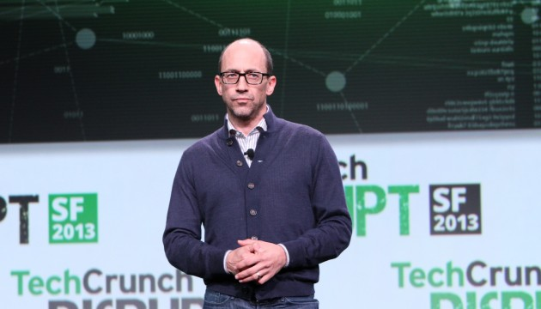

Twitter has filed papers to take the company public. This changes everything, right?

Wrong.

It's a momentous milestone for the six-year-old [message-broadcasting company](http://www.bizstone.com/2007/04/twitter-inc-obviously.html), to be sure, and a credit to the steady leadership of CEO Dick Costolo, who followed two of the company's founders in that role. But for users and developers, the IPO doesn't mean much.

**Change Is Good—But Simplicity Is Better**

As a product, Twitter won't change much following a public stock offering. The 140-character format of a tweet is set in stone, though Twitter has figured out clever ways to associate images, videos, and other forms of media with these short posts. Recent changes, like a more intelligent display of tweets sent as replies in the form of a conversation, seem more like obvious tweaks than big changes.

And while Twitter has grown more sophisticated in selling advertisements, ads on Twitter come in the form of tweets, which keeps things simple. Where Twitter will improve its advertising products is in how they're targeted to particular users.

**Twitter Will Keep Snapping Up Startups**

Right before it revealed going public, Twitter announced it had bought online-advertising startup MoPub in an all-stock deal. It's been on an acquisition spree for a while, buying up startups like Vine, the short-video broadcasting service, and Crashlytics, maker of tools for mobile-app developers.

Between the cash Twitter has raised from investors and the high valuation placed on its privately traded shares, it already has the financial firepower to buy startups to expand its business and its pool of talent. An IPO will accelerate that trend, but it won't change its direction.

**Investors Will Get Rich**

Twitter's venture-capital investors, like Union Square Ventures and Charles River Ventures, will profit enormously from an IPO (and from their patience in not selling). But it's their job to make money for their own investors—pension funds and other large institutions that need to diversify their investment portfolios. While it's great that VC firms are making money, it doesn't really change much for the rest of us.

**Twitter Will Stay Independent**

As a publicly traded company, Twitter has a better chance of staying independent. But it got too big to buy a while ago, based on the valuation its private investors have assigned to it.

Over the years, Facebook and Google made stabs at buying Twitter; there were talks with others, like Yahoo, that never went particularly far. That was billions of dollars ago. At this point, it's too hard for Twitter to sell. Its private valuation is estimated at between $10 billion and $14 billion; it will likely be worth more than that as a public company.

At the same time, that's way too much money for any public company answerable to its shareholders to spend on an acquisition, given the state of Twitter's advertising revenues. (Estimates vary in the range of $300 million to $600 million this year; we know that to file confidentially with the SEC as an emerging-growth company, Twitter's annual revenues must be less than $1 billion.) If Twitter will sell, it must first grow into the valuation eager investors want to assign to it.

**What Will Change**

The one factor that's hardest for Costolo and the rest of Twitter's executives to manage will be its people. AllThingsD reports that some Twitter employees [recently received new stock grants](http://allthingsd.com/20130913/twitter-doles-out-stock-grants-to-keep-top-talent/) to keep them at the company well past an IPO.

Some engineers, product managers, and salespeople who enjoy the wild ride of a startup simply won't want to stay at a company of the size a publicly traded Twitter will inevitably become. Were Twitter to find some way to delay its stock-market debut, they would likely leave anyway, as Twitter grew; that's been happening for some time, even as Twitter hires employees by the hundreds.

If a public Twitter wavers in defense of its users against government agencies, employees could rapidly grow disillusioned. And that, in turn, could weaken the company's growth.

The good news is that going public may be the best defense Twitter has against such pressure. Acquired by a larger entity, Twitter might fold to protect some other aspect of the parent company's business. As long as those who buy Twitter's stock understand the legal risks it faces in championing free speech around the globe, little should change just because Twitter acquires a ticker symbol.

*Source: http://readwrite.com/2013/09/13/twitter-ipo-changes#awesm=~omPQMgmcZRPE10*

Question 1

a) Define the following terms:

*public company.* [2 marks]

*acquisition* [2 marks]

b) Identify the sector of the economy occupied by businesses such as Twitter. [2 marks]

c) Explain *two* sources of finance previously available to twitter as a private company [4 marks]

d) Analyse two advantages and two disadvantages of a business like Twitter ‘going public’. [6 marks]