Intercontinental Fairmont 15

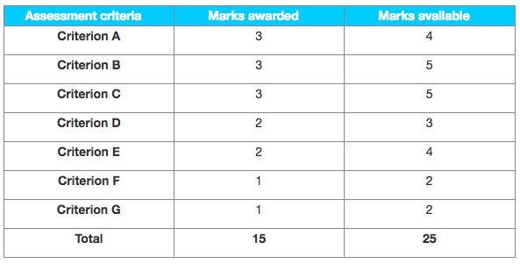

Examiner comments

**This extended essay is worth a 5, with a clear margin for improvement. The research question and the supporting documents have a lot of potential; the candidate could have scored higher here.**

**Criterion A – Supporting documents**

A decent selection of supporting documents, with both quantitative and qualitative data; they are relevant and sufficient in depth, however they do not present a range of views (they all argue that the acquisition is a good idea so this is too one-sided).

**Criterion B – Choice and application of tools, techniques and theories**

Appropriate coverage of conceptual aspects (globalization) with some financial information; the FFA is a good tool to help answer such a strategic question (the fact that it is in the HL extension syllabus is not a problem) however the coefficients given to all the forces are not entirely clear, hence a “best fit” of 3 marks.

**Criterion C – Use and analysis of data and integration of ideas**

Satisfactory analysis; a mark of 4 could have been considered as pros and cons are mentioned, which implies some integration, however the teacher awarded 3, not 4, and the moderator had no strong reason to disagree and to change that mark (especially as some passages were rather too descriptive, such as on page 4).

**Criterion D – Conclusions**

The short conclusion page 6 answers the research qustion (“…seems to be a good decision”) however it summarizes the FFA too much and ignores other factors (globalization, finance), hence 2 and not 3 marks.

**Criterion E – Evaluation**

Not all judgements are backed up by a source/evidence, most noticeably in the FFA.

**Criterion F – Structure**

The structure is not optimal—and not always easy to follow, especially in the first part (pages 3-4), prior to the FFA.

**Criterion G – Presentation**

Referencing in the text itself is lacking; the supporting documents are not clearly labelled/numbered (though relevant passages are duly highlighted). Besides, the cover sheet was confusing (the candidate had written “HL Research Project”.