**Unit 1.1 – Introduction to business management**

**Syllabus Objectives**



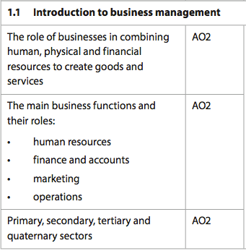

Know the inputs process of value adding. Be able to break concepts down into individual characteristics and see the broader picture how they relate. E.g. farmers and the primary sector require more land and less capital than a factory.

Know the process of value adding and understand how value is added for a variety of businesses. Be able to break concepts down into individual characteristics and see the broader picture how they relate. E.g. hairdressers rely on HR to add value, whereas Apple Inc. relies heavily on marketing

Know the sectors of the economy. Be able to break concepts down into individual characteristics and see the broader picture how they relate. E.g. less developed countries have greater primary (grow food) and tertiary (sell food) sectors, whereas modern economies have greater quaternary (intellectual services) sector.

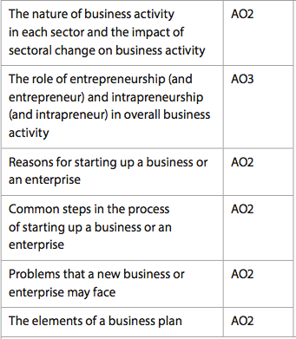

Know that countries pass through different sectors as their economy industrializes and then deindustrializes. Be able to break concepts down into individual characteristics and see the broader picture how they relate. E.g. the need for a larger workforce is needed as a country industrialises and moves into secondary sector, whereas the workforce needs more education when advancing into the quaternary sector





Know the features/traits that make up an entrepreneur and an intrapreneur. Be able to combine and synthesize these ideas into a new idea and make a judgment based on the weight of evidence. E.g. determine the need for en/intrapreneurs in a modern functioning economy based on the skills they hold.

**Example questions may include:**

Define the term *Tertiary Sector*  [2 marks]

Explain why sources of finance is important for a business plan [6 marks]

Analyse the impact on luxury retailers in China as the country begins to

deindustrialize [6 marks]

Discuss the role entrepreneurship has played in the development of

Technology based companies in the past 3 decades [10 marks]

Know the business plan draws on the financial, marketing, HR, product and other business functions. Be able to break concepts down into individual characteristics and see the broader picture how they relate. E.g. If the business is a service, more attention should be given to HR aspects than some other areas.

Know the problems new business face, such as financial, cash, customers and marketing issues. Be able to break concepts down into individual characteristics and see the broader picture how they relate. E.g. Cash flow in the beginning of a businesses life is often challenging as the business is unable to get credit and the customer base is still low. Improving one area may impact positively on other problem areas.

Know the steps and reasons why people go into business – like GETCASH. Be able to break concepts down into individual characteristics and see the broader picture how they relate. E.g. If more freedom is a reason to start a business, then the detailed steps, such as writing a business plan, may conflict with the original idea.