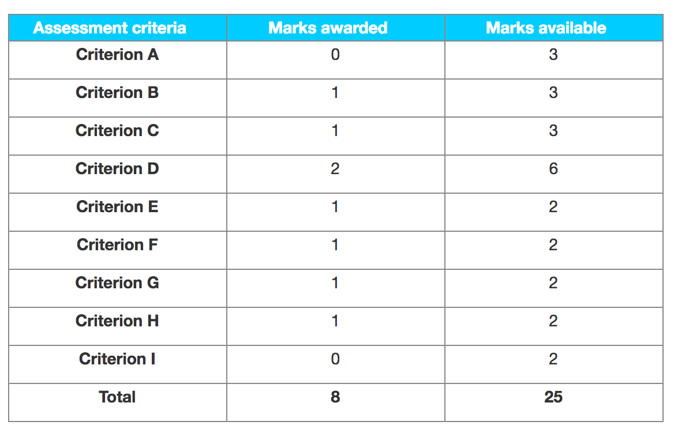

Criterion A – Research proposal

The candidate has not followed the format required as none of the 4 sections indicated on pages 80–81 of the guide are present — these sections are:

"Research question", "Proposed methodology", "Anticipated difficulties" and "Action plan".

Criterion B – Sources used and data collected

The candidate has only included evidence of one element of primary research — an interview with the owner of Tipton Turf.

Criterion C – Use of tools, techniques and theories

The candidate included a SWOT analysis, which lacked depth, and an Ansoff Matrix which was descriptive rather than analytical. The candidate discussed if Tipton should merge with a local competitor, which demonstrated limited analytical skills. Overall, there is a limited understanding of business management tools and these are superficially applied.

Criterion D – Analysis and evaluation

There is an attempt to analyse, using the SWOT analysis. The candidate also discussed the advantages and disadvantages of a merger. However, this analysis lacked depth and is essentially superficial. The results and findings presented by the candidate are limited.

Criterion E – Conclusions

The candidate did come to the conclusion but the question set was on “Should Tipton Turf Expand?”. In the conclusion, the candidate discussed the best option to reach its maximum production. The candidate did not come to a single clear conclusion but in terms of best fit it is 1 rather than 0.

Criterion F – Recommendations

The candidate did make a recommendation (the best solution would be to locate the company’s beef into a local burger chain or steakhouse) but then in the next paragraph said that “Tipton should merge with a local competitor”.

Criterion G – Structure

The candidate’s arguments were not easy to follow. There was some attempt at structure and the candidate has already been penalised under criterion A.

Criterion H – Presentation

The sections of the report were not in the correct order, for example the contents page came before the acknowledgements.

Criterion I – Reflective thinking

The candidate did not present any evidence of reflection on the approach taken in this piece of research and its limitations.