ASOS Delivery 22

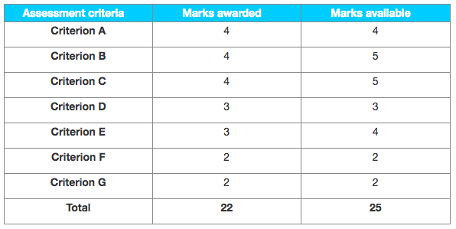

Examiner comments

**A very good SL IA that is clearly worth a level 7. Only minor aspects could have been better (especially for B).**

**Criterion A – Supporting documents**

The five supporting documents are all recent and relevant, they are sufficiently in-depth and from a range of sources. The views they present are arguably varied enough to justify 4 marks; the teacher had awarded “only 3” but did not explain why (there was no comment and annotation on the IA); the moderator decided to raise this mark from 3 to 4 as it is not clear what else could have been provided here, for example what sort of other SD would have been needed to score higher.

**Criterion B – Choice and application of tools, techniques and theories**

A range of tools and concepts that are very well applied, notably SWOT and ratios; only minor aspects could have been better (for 5 marks), such as a) comparison over some years for some of the ratios in order to identify trends or patterns, or b) some inaccuracies in the SWOT where some opportunities are internal.

**Criterion C – Use and analysis of data and integration of ideas**

To quote the descriptor for 4 marks: “There is an appropriate selection of data from the supporting documents with good analysis and some integration of ideas.” A mark of 5 could have been considered by the teacher, who nonetheless did not do so; the moderator’s job is to agree with the teacher’s marks unless they have strong reasons to disagree, which is not the case here, so 4 stayed unchanged.

**Criterion D – Conclusions**

The conclusion page 9 answers the question very clearly, recapping the key points without adding new elements.

**Criterion E – Evaluation**

There is evidence of evaluation all along (for example in the section “customer and competition analysis” on page 8: “the risk is enhanced by… this is due to…”). The teacher awarded 3 and the moderator agreed, although a mark of 4 could have been considered.

**Criterion F – Structure**

Logical structure, easy to follow.

**Criterion G – Presentation**

In particular: very well referenced (see all footnotes).