**Unit 2.1 Functions and evolution of human resource management**

Know that HR planning is about having the correct number of employees, with the right skills and experience, into the right job, at the right time and place for the right cost. Be able to describe this predicament faced by HR managers. E.g. HR planning is one of the most time and resource consuming aspects for international school management. In December, before your first report card comes out, they are determining how many students in what classes and grades they will have for the next year in order to recruit the right number and quality of teachers to teach them.

**Syllabus Objectives**



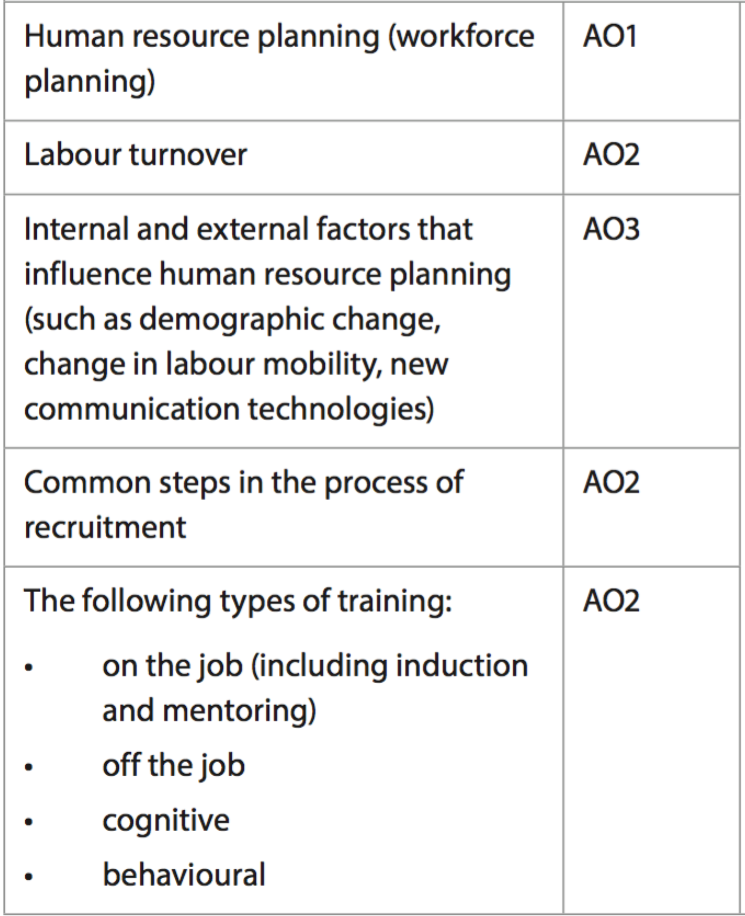

Know that labour turnover is a calculation of the number of staff who exit a business compared to the average total number of employees, expressed as a percentage. Know some of the causes and impacts of both high and low labour turnover rates. Be able to break concepts down into individual characteristics and see the broader picture how they relate. E.g. International education, like most industries, is simpler to manage when labour turnover rates are low. This means that managers spend less time and money on recruitment, money spent on training is maintained within the school, and students become more familiar with their current teachers, improving their learning. However, challenging teaching locations, poorly managed schools, vastly different financial rewards and lack of leadership opportunities can result in some schools having devastatingly high labour turnover rates.

Know that demographic change (age, gender, population, marital status), mobility changes (globalization, improved transportation, attitudes to travelling for work) and communication (work from home, work on-site, easier to contact family members) are all contributing to the growth in the global labour market and the opportunities available to business managers in staffing. Be able to combine and synthesize these ideas into a new idea and make a judgment based on the weight of evidence. E.g. The UAE has become a desirable place for migrant workers from LEDCs. The high population of young people in English speaking countries without access to employment, combined with the economic growth and low population of the UAE has allowed UAE government and business to provide work opportunities across a vast range of industries. Workers from India, Pakistan and other South-Asian nations are involved in the construction industries, whereas workers from the Philippines often work in hospitality and service industries. Workers are drawn to the UAE for higher salaries, safety and are still able to communicate home easily. Businesses need to invest heavily in their recruitment, training, housing and wages, which can be challenging, and problems sometimes occur.

Know the common steps in the recruitment process, identification, application and selection, as well as the respective strengths and weaknesses of internal vs external recruitment. Be able to break concepts down into individual characteristics and see the broader picture how they relate. E.g. A long, drawn out recruitment process may be more effective in specialist positions, such as recruiting for intelligence services. Job descriptions need to be very detailed and the application may need to be more challenging. The selection phase may include aptitude testing, interviews, psychological testing, skills testing and vetting prior to obtaining a position. This could take months, incur high costs and require the time of many individuals. This is important in order to determine the right people for the job. The same process for a fast-food restaurant would be too costly, time consuming and impractical for the caliber of employee required.

Know the strengths and weaknesses of the types of training, on and off-the job, as well the methods of training, cognitive and behavioural. Be able to break concepts down into individual characteristics and see the broader picture how they relate. E.g. Organisations need to offer a combination of both on and off-the job training. Usually employees who go away for training, which can be expensive and may require travel, will pass on their new knowledge to other employees upon their return. This has benefits, especially for the initial trainee, as they received the training directly from the professional, and they can strengthen their own understanding by delivering the training again to others. For the new trainees, they are receiving up-to-date and relevant training, but it is second hand and may lack the skill and motivation. Online training is becoming massively popular due to its much lower costs and ability to be done anywhere or anytime. But many argue the restraints on time, and the distractions and lack of motivation online training create are weaknesses.

Know the common types of appraisal, as well as their relative strengths and weaknesses. Be able to break concepts down into individual characteristics and see the broader picture how they relate. E.g. Summative appraisals require clear objectives to measure the employee’s performance against. Each objective requires a clear form of measurement to determine whether success has been achieved. To perform regular summative appraisals will require ongoing checks of the employee’s work, as well as frequent interviews to provide feedback. This may be impractical for most employees, as it is time consuming and creates a lot of unnecessary pressure on the employee. This may be different during the early ‘probationary’ phase of the employees contract, whereby it is important for management to determine they have a suitable employee before offering an extended contract.



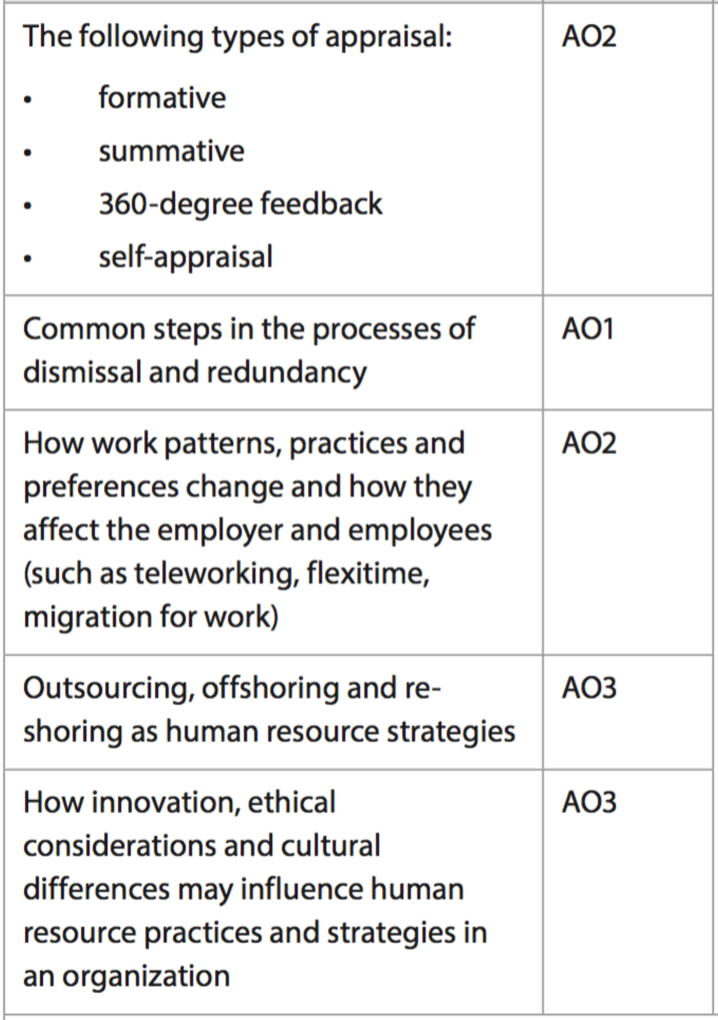

Know that employees split from employers in three main styles, termination, dismissal and redundancy. Know the reasons behind each form, dismissal = fired, whereas redundancy can be voluntary or involuntary. Be able to identify and describe these features. E.g. Redundancy often brings a payment to the employee, as they are being forced to leave for no fault of their own. This payout may depend on the length of time the employee has at the organization. Although it may cost more to make long-serving employees redundant, it may provide an opportunity to foster younger employees.

Know that the way employees work is changing, driven by communication, transportation, migration and the search for a suitable work/life balance. Specifically, be aware of teleworking, flexitime and migration. Be able to break concepts down into individual characteristics and see the broader picture how they relate. E.g. Many professional positions in the past required employees to work in large cities, however, most employees cannot afford to or choose not to live in the centre of the city. This created long commutes to work, negatively impacting employee wellbeing and extending the workday. Communication and Internet technology have opened up opportunities for employees to work at a range of locations, including home. For many, this can reduce the length of the workday and improve time spent on other activities, like spending time with family.

Know that labour costs in labour intensive industries can be the largest cost to a business, and identifying ways to locate cheaper labour can be critical to business success, such as outsourcing and offshoring. Also know that cheaper labour in another country or location has been challenging for many organisations, leading to reshoring for some aspects of the business operations. Be able to combine and synthesize these ideas into a new idea and make a judgment based on the weight of evidence. E.g. A computer programmer in the USA could be paid $4,000 a month, whereas in India, the same employee earns $1,000 a month. The financial decision to offshore the work is an easy one, however, there may be difference in the quality (or at least perceived quality) of the work. Communication also becomes more challenging due to time and cultural differences.

Know that innovation can apply to HR strategy, know that ethical considerations about the treatment of workers or candidates must be considered and that people from different cultures (countries and past employers) might have a different understanding in the employer/employee relationship as well as work expectations. Know about the work of Hofstede regarding the role of national culture on organisations. Be able to combine and synthesize these ideas into a new idea and make a judgment based on the weight of evidence. E.g. Many laws have been created around discrimination in recruiting, especially against women. Ethical organisations are hiring women as well as providing benefits should they start families etc that exceed the law, and are finding better recruits for positions.

**Example questions may include:**

Define the term *labour turnover*  [2 marks]

Distinguish between *formative and summative* forms of appraisal [6 marks]

Analyse two weaknesses of the recruitment process for company X [6 marks]

Examine the impact of the growing middle class on factory employee recruiters

in China [10 marks]

Evaluate company Y’s decision to outsource customer service operations [10 marks]