Beoing

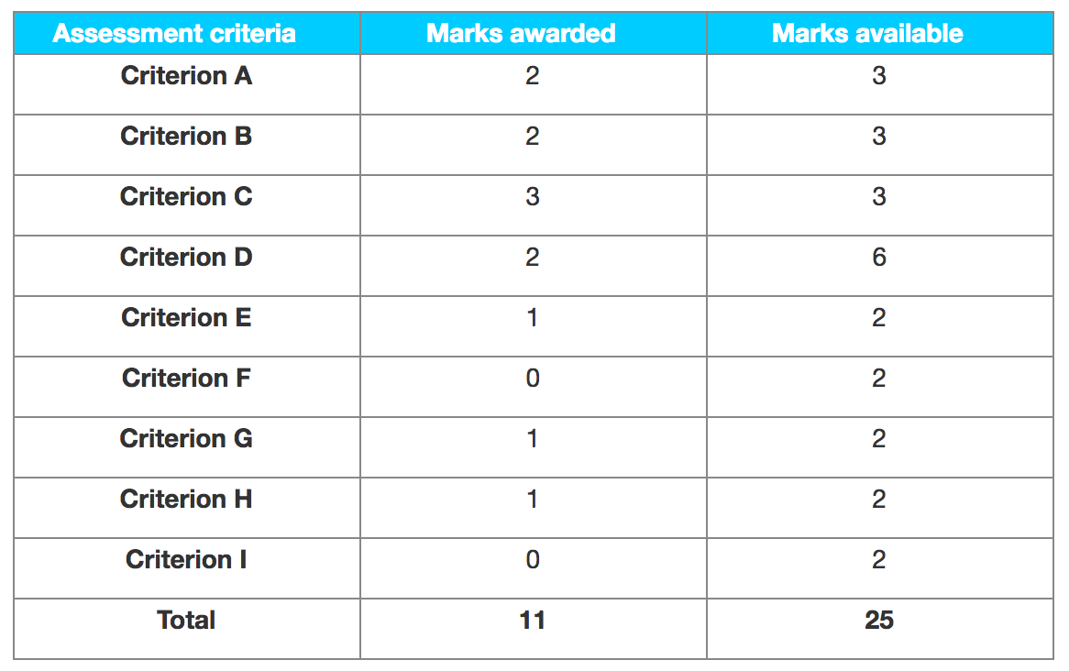

Examiner comments

Criterion A – Research proposal

The research proposal is generally appropriate but the theoretical framework section lacked detail and the action plan was superficial.

Criterion B – Sources used and data collected

The primary data collected is appropriate, but is not varied and sufficient. No credit was given for SWOT and Steeple analyses as these were the student’s own work. There was evidence of an interview and a balance sheet and income statement.

Criterion C – Use of tools, techniques and theories

There were SWOT and Steeple analyses, a Fishbone diagram and a Force Field analysis—for the latter, there was no explanation of from where the values were obtained. There was also evidence of profitability and efficiency ratios but these were of questionable relevance to the research question. This was borderline 1 or 2 marks. Overall a best fit of 2 marks.

Criterion D – Analysis and evaluation

The results and findings are limited. There was some attempt at analysis but this was superficial and overall there was a lack of integration of ideas—for example, what is the relevance of efficiency ratios for this study?

Criterion E – Conclusions

The candidate has drawn a conclusion but it is unsubstantiated and lacks clarity.

Criterion F – Recommendations

2 There are no clear recommendations made and no section or subheading labelled as recommendations.

Criterion G – Structure

The overall report is structured but the argument presented is not easy to follow.

Criterion H – Presentation

The bibliography was placed after the appendices.

Criterion I – Reflective thinking

The candidate did not present any evidence of reflection on the approach taken in this piece of research and its limitations.