**Unit 4.3 Sales Forecasting**

**Syllabus Objectives**

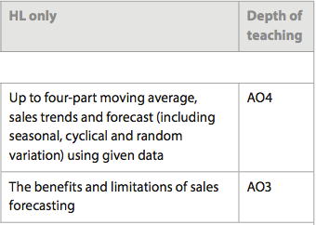

Know that the future sales of a business need to be forecasted in order to prepare strategic plans. Also know that these forecasts are prepared to recognize variations that happen day-to-day, or month-to-month due to seasonal, cyclical or random events. 3-part is often used for three-month periods, also known as *quarterly*. Be able to construct both a 3-part and 4-part moving average sales forecast and comment on the findings. Also be able to ‘extrapolate’ the data by making future forecasts based on the calculated trend.

Know that sales forecasting has a long list of benefits, most notably it can improve cash flow, human resource planning, stock control and finally help a business obtain external finance whether a new or existing business. Furthermore, recognize the limitations, which include the quality of the information in the forecast, the inability to predict random variations due to external influences and the limited ability to forecast accurately for the longer term. Be able to combine and synthesize these ideas into a new idea and make a judgment based on the weight of evidence. E.g. A fashion company will forecast its future sales of its dresses in order to plan for the level of raw materials needed and the amount of finished goods needed in stores at one time. Sales forecasting for fashion is very difficult due to changing styles and trends and is difficult to predict sales even in the short term. Furthermore, seasonal variation needs to be considered in the forecasts due to weather changes. However, if a celebrity is seen wearing a fashion item the same as or similar to a product made by the fashion company, this is most likely to result in a random variation and it is highly probable the product is understocked and will sell out very quickly leaving some customers disappointed that they missed out.

**Example questions may include:**

Define the term *random variation*  [2 marks]

Prepare a sales forecast for Company X using four-part moving average and

extrapolate an additional 6 months ahead [6 marks]

Discuss whether sales forecasting for the next 2 years is suitable for a global auto

manufacturer such as Ford [10 marks]