**Unit 5.3 Lean production and quality management (HL only)**

**Syllabus Objectives**

Know that less waste and greater efficiency both apply to materials, energy, time and labour inputs. Be able to describe these terms and the recognisable features of a business that incorporates lean production. E.g. A bakery will have one employee arrive earlier to turn on the ovens, with the remaining employees starting later when the overs are heated – this reduces labour wastage.

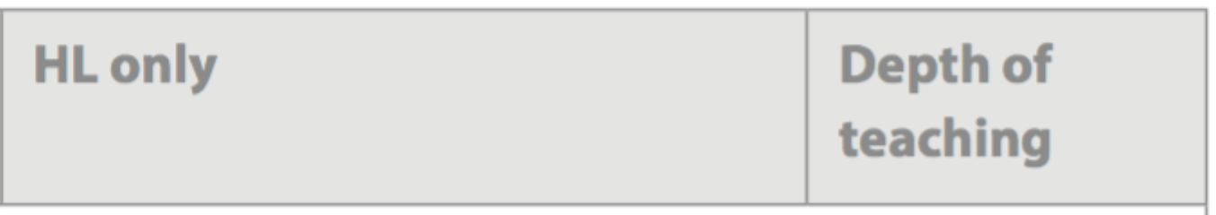

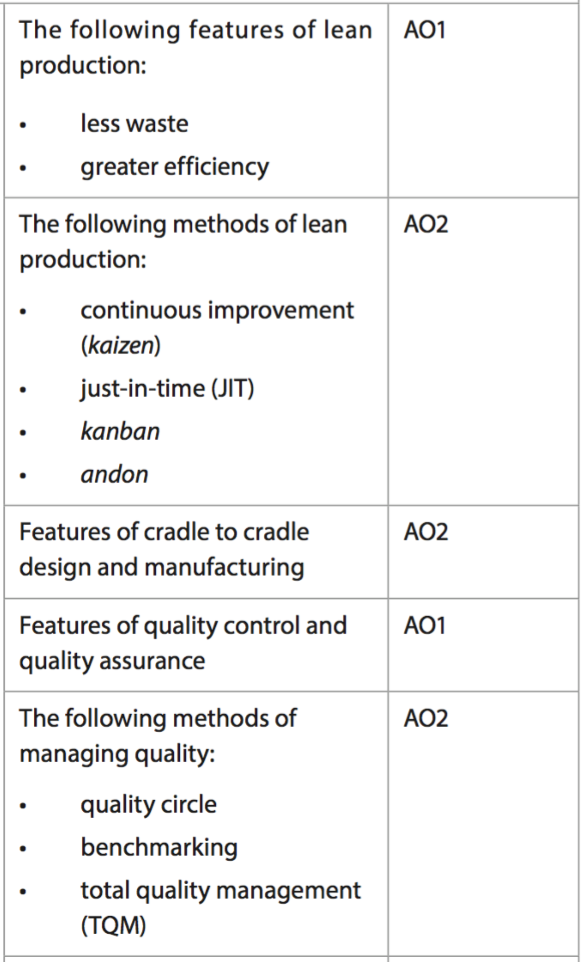

Know that there is a range of methods businesses implement lean production, and that a completely lean organization is likely to combine all of them. Be able to break concepts down into individual characteristics and see the broader picture how they relate. E.g. Toyota has developed many lean production processes during its time, hence why these methods have Japanese names. As it continually improves, Toyota finds new ways to reduce the amount of time stock spends on the factory floor via a JIT method. It tracks orders and workflow using software, based on the *kanban* card management system. On the factory floor, workers manage workflow using visual and auditory systems, known as *andon*. Problems in the production process result in flashing lights and buzzing noises to identify and resolve problems as quickly as possible. They aim to have zero defects throughout the production process.

Know that cradle-to-cradle refers to sustainable practices of both manufacturing the product, as well as the products life. Cradle to cradle products should not have just one life, but have further uses. Products with one life are known as cradle-to-grave. Be able to break concepts down into individual characteristics and see the broader picture how they relate. E.g. Lauffenmuhle (L), a German textile manufacturer has developed textiles blended from certified wood and biodegradable synthetic polymers made from non-edible plants. These are used for work wear, such as hospital uniforms, which require rugged, but not necessarily glamorous materials. They also last less time and need to be produced in larger quantities. By making these biodegradable, L is mass-producing a sustainable yet high quality product, demonstrating CSR and giving themselves a competitive advantage over other suppliers.

Know that *quality control* is the traditional method of the operations department catching any problems with products before they reach the consumer, whereas *quality assurance* is the modern way of preventing problems with the quality of products at the beginning of the production process. Be able to describe these terms and the recognisable features of a business that incorporates each method. E.g. Dubai School’s Inspection Board carry out annual quality control by sending a team of education specialists to analyse the performance of the school against a pre-determined criteria. Higher quality schools will be given higher ratings.

Know that developing a quality culture promoting quality process requires input and opportunities from management. Know that businesses may incorporate individuals to work collaboratively in quality circles; measure results against benchmarks and spread the culture of quality beyond operations into all functions of the business. Be able to break concepts down into individual characteristics and see the broader picture how they relate. Then be able to combine and synthesize these ideas into a new idea and make a judgment based on the weight of evidence. E.g. The production of pharmaceuticals is one of the most quality-driven industries. Pharmaceuticals have to pass the highest of final standards to be used on humans, so Quality Assurance begins right from the design stage and is ongoing through production and testing. This also gives the public confidence that the drug is safe and provides the benefits as advertised. On the other hand, this level of QA is very expensive and time consuming, with some drugs taking up to 10 years or more to pass final tests. These companies must hire numerous employees to complete this work, as well as design, create or purchase expensive equipment to ensure quality is maintained. It is not possible to simply just check for defects at the end of the production process in this industry.



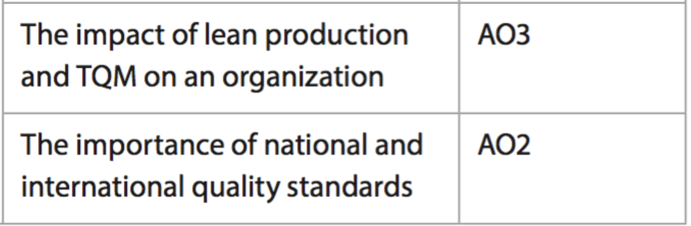

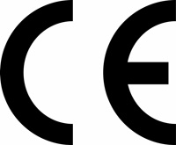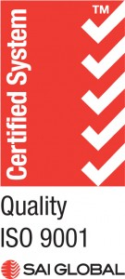****

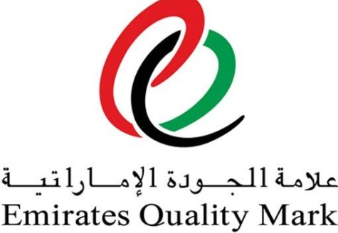



Know that businesses choose to have their products tested against national or international standards in order to show customers the product is of a high quality. A logo will be on the product to show it has passed the test (like the examples above). Be able to break concepts down into individual characteristics and see the broader picture how they relate. E.g. All pen lids in the UK must have a hole in the top to reduce the risk of children (and adults) choking if they swallow it. Standards are important as they provide consumers the knowledge of which companies produce safe, high quality products. Some quality standards, such as ISO 9000, also acknowledge that the whole company uses best practices. This makes the product safer for families and provides a clear model that producers must follow.

**Example questions may include:**

Define the term *Total Quality Management (TQM)*  [2 marks]

Explain two benefits to company X of using quality control in its operations [4 marks]

Explain two reasons why Company Y chose to adopt International Standard 9000 [4 marks]

Analyse whether Company Z should apply *kanban* and *andon* systems in the

Production of its home appliances [6 marks]

Discuss whether continuous improvement will reduce iPhone defects for Apple [10 marks]