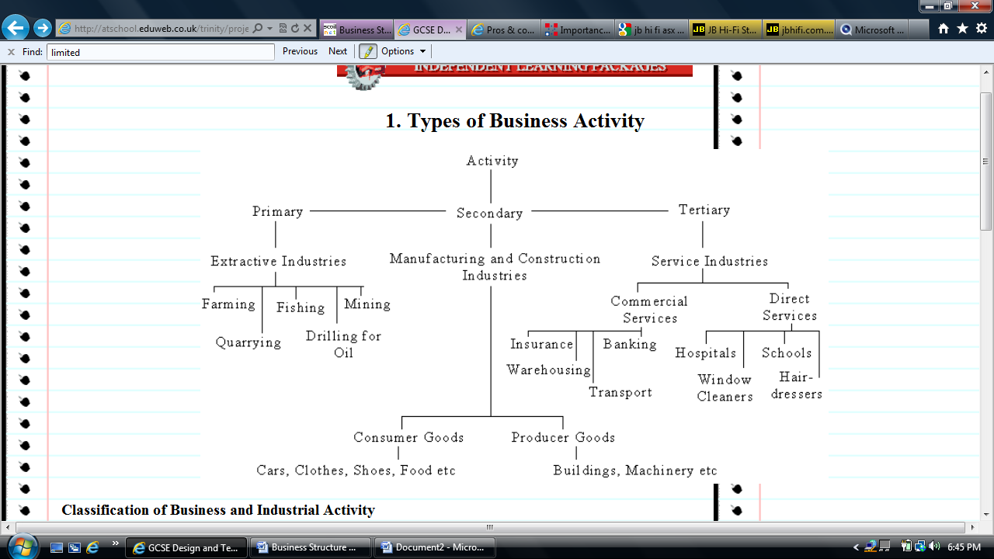

Knowledge Industries

Quaternary

Scientific services (R&D)

I.T.

Financial planning

Business consulting

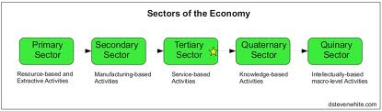

1. State the type of industry(ies) would you expect to find at Dubai Mall. Use diagram above.

...........................................................................................................................................................

2. Comment on why primary industries are usually found outside cities. Think about inputs.

..................................................................................................................................................................

..................................................................................................................................................................

..................................................................................................................................................................

1. Determine what sector of the economy the following business activities might belong to:

|  |  |  |  |
| --- | --- | --- | --- |
| Coal Mining Bus network Textile factory Architecture Restaurant | Construction business Aged care nursing Oil Rig Diving Leisure Diving Commercial Bakery | Department Store Cancer Researcher  Quarry Worker Jewellery Store  Farm | Bank Fishing trawler Taxi Driver Jewellery maker  IT Consultant |
| **Primary** | **Secondary** | **Tertiary** | **Quaternary** |
|  |  |  |  |

4. Complete the chains of production by drawing an image

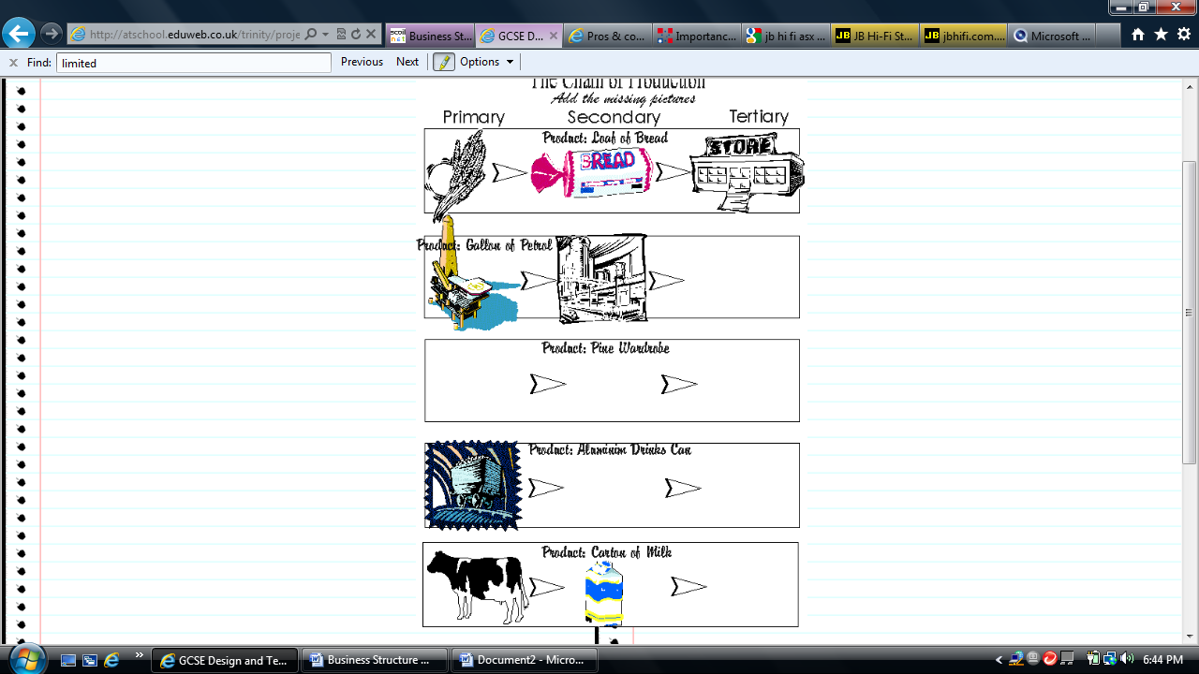

5. Describe the term *chain of production*

...................................................................................................................................................

...................................................................................................................................................

...................................................................................................................................................

Extension – Explain two reasons why 1 business might control its entire chain or production