**Unit 3.9 Budgets (HL Only)**

**Syllabus Objectives**

Know that budgeting is important for 4 main reasons: Planning (Setting financial targets in numerous areas of the business), Coordinating (allocating people, money and resources to where they are needed), Controlling (Checking if plans are on track and making adjustments if necessary and Motivating (Giving employees responsibility). Be able to break concepts down into individual characteristics and see the broader picture how they relate. E.g. Setting budgets may motivate managers as targets are set (e.g. lower employee costs) and there may be additional financial or non-financial rewards if the targets are met. However if a manager is able to achieve a result much lower than the target, they may be penalized in the following period with a much lower target, and this may create demotivation



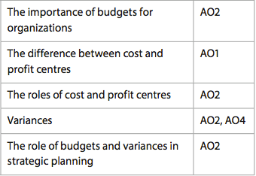

Know that business break down profit and loss accounts into different sections based on products, geography and other factors. Know why they do this, to be able to identify strengths and weaknesses of the business, improve budgeting and make better strategic decisions. Be able to break concepts down into individual characteristics and see the broader picture how they relate. E.g. cost centres allow production managers to compare their efficiency across different product lines, however it may be difficult to allocate some costs to certain products. Furthermore, profit centres also require revenue to be allocated. This may be difficult to determine, and is also difficult to apply to production as there are elements of promotion, price and place that are not controlled by the production team.



Know that a variance is the difference between a budgeted value and an actual value. Variances can be favourable or adverse. Higher revenues are favourable, higher expenses are adverse and other values can also be budgeted for. Also know that budgets are critical in strategic planning, and budgets will be created in order to justify growth strategies, obtain sources of finance and plan a workforce. Be able to calculate variances and be able to break concepts down into individual characteristics and see the broader picture how they relate. E.g. Budgets need to show high revenues and profits to attract finance and justify growth, however, high budgeted revenue adds pressure to managers who are responsible for meeting these targets.

**Example questions may include (HL):**

Define the term *variance*  [2 marks]

Distinguish between a profit centre and a cost centre [6 marks]

Explain two reasons why budgeting is important for Company X [6 marks]

Analyse two benefits of the manager increasing budgeted revenue for next year [6 marks]