Victory Supermarket

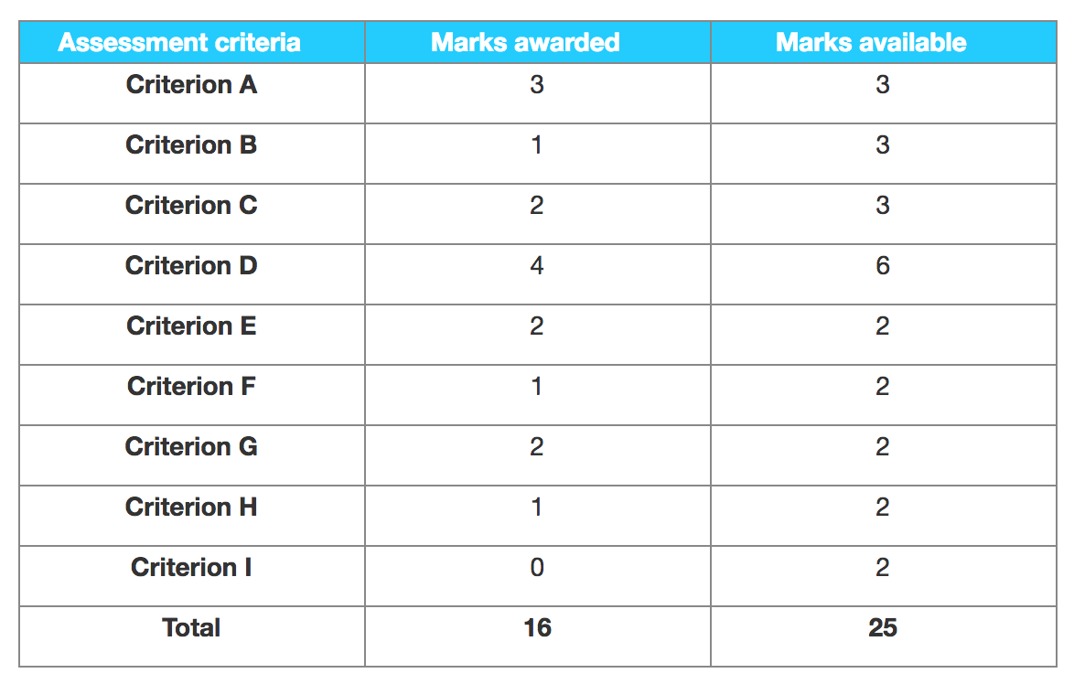

Examiner comments

Criterion A – Research proposal

The research proposal has all the required elements. The methodology and theoretical framework sections are succinct and appropriate. The action plan is quite brief but just sufficiently detailed. Overall this is borderline between the 2 and 3 markband and was given 3 on a best fit approach.

Criterion B – Sources used and data collected

The candidate has included evidence of an interview with the manager. The other three documents in the appendix were the candidate’s own SWOT, PEST and Force Field analyses. Therefore, overall only one example of primary research was included.

Criterion C – Use of tools, techniques and theories

The candidate included an investment appraisal using payback, average rate of return. These were all suitably applied.

Criterion D – Analysis and evaluation

There is a satisfactory analysis of the results of the investment appraisal methods used and some integration of ideas. There was just sufficient evidence of evaluation on page 17 to raise this to 4 marks.

Criterion E – Conclusions

Conclusions were drawn with clear reference to the evidence found in the body of the report, the payback period and average rate of return. However the discussion of the Force Field analysis was not credited as the Force Field document was in the appendix rather than the body of the report. Overall, a best fit mark of 2 was awarded.

Criterion F – Recommendations

There were recommendations made but these were largely unsubstantiated.

Criterion G – Structure

The candidate produced a structured report with an argument that was easy to follow.

Criterion H – Presentation

The report is missing a section on the chosen methodology and the research proposal is not in the right place as it should be positioned before the acknowledgments.

Criterion I – Reflective thinking

There was no appropriate evidence of the candidate reflecting on the approach taken in this piece of research and its limitations.