**Unit 2.6 Industrial/employee relations (HL only)**

Know that trade unions will represent many employees in many lower-medium level jobs such as factory workers, tradesman, retail staff, teachers and many more, where there is a large number of staff receiving wages and salaries based on age and experience. Know that employers will also use specialists to manage and negotiate with trade unions. Be able to break concepts down into individual characteristics and see the broader picture how they relate E.g. Trade unions are accountable to their paying members, and seek out increased wages, improved lifestyle conditions (such as holidays, maternity etc) and better safety conditions. However, employer representatives are accountable to the employer, who is ultimately accountable to the shareholders, so they seek to minimize costs. Employers who negotiate with trade unions are almost always large in size, so more likely to be large companies or public corporations

**Syllabus Objectives**

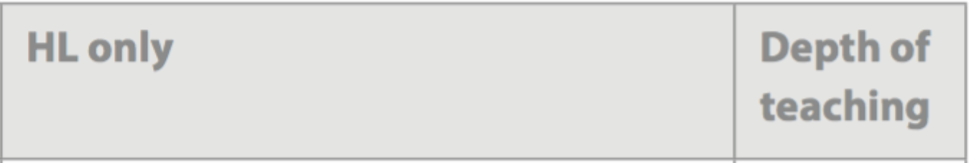

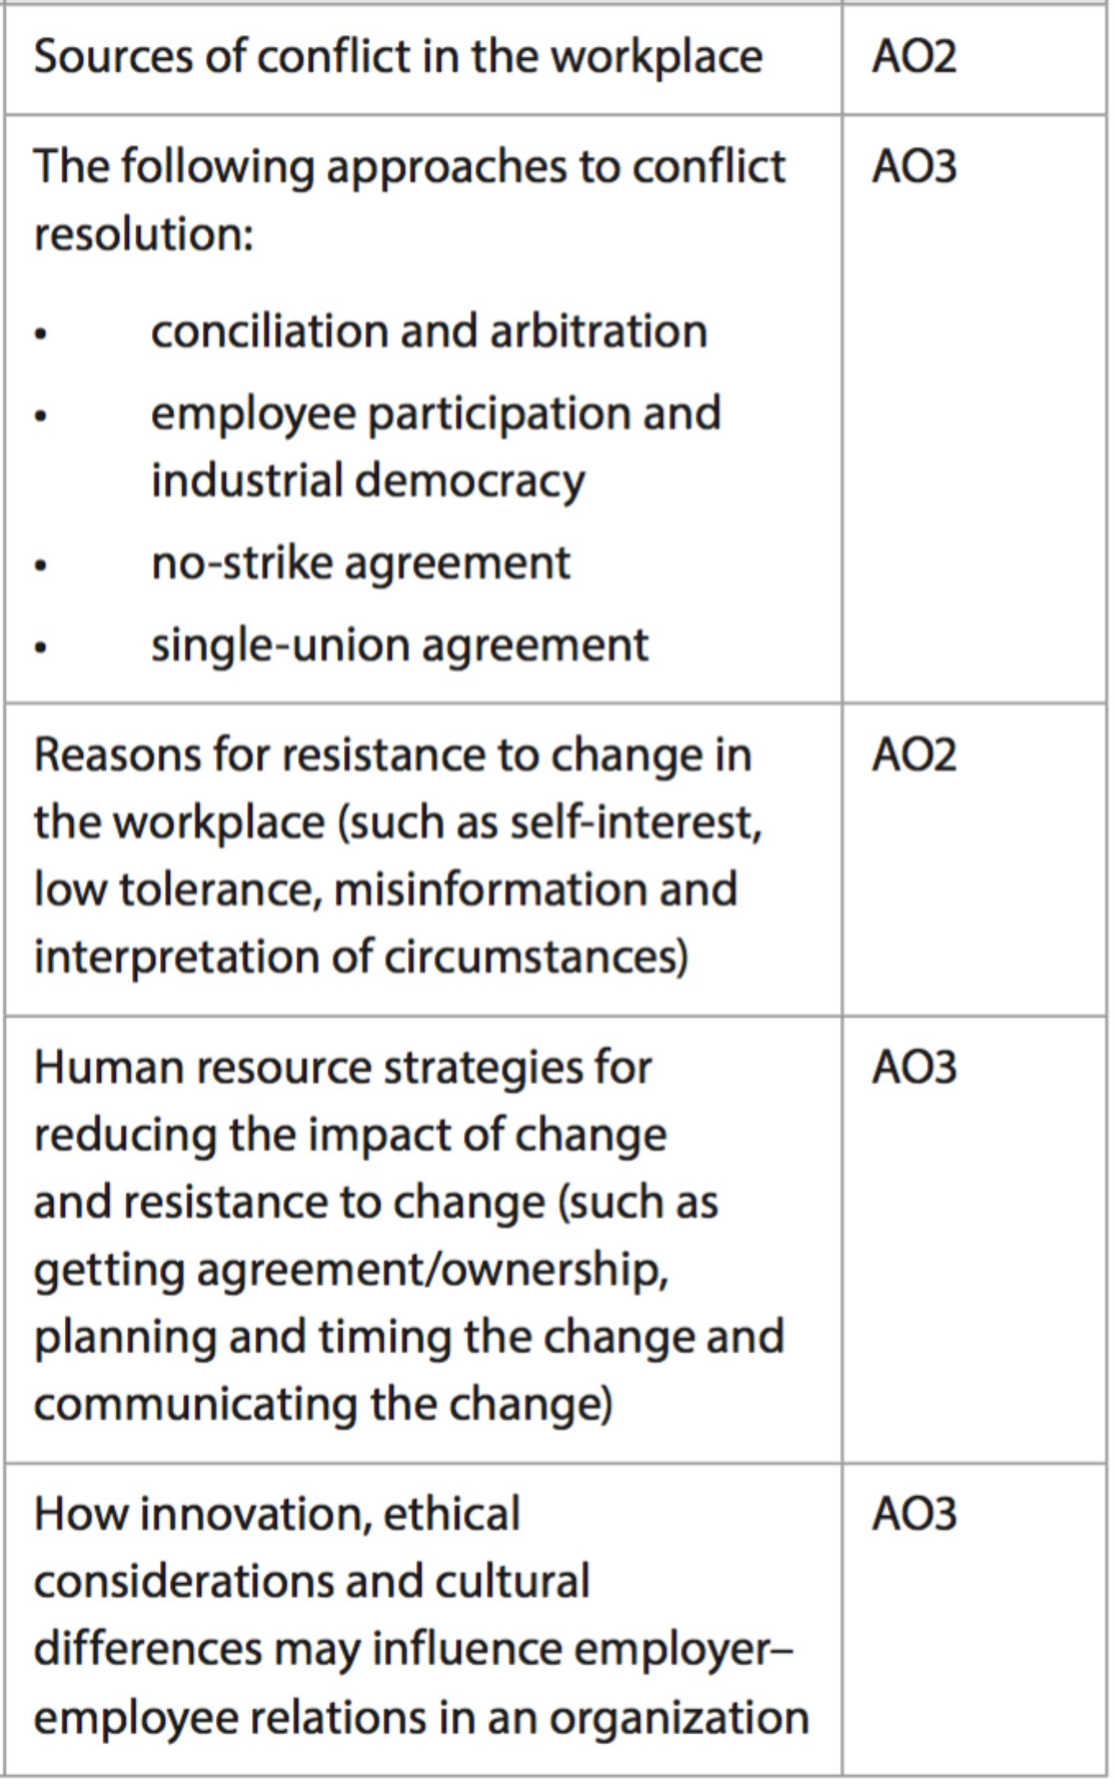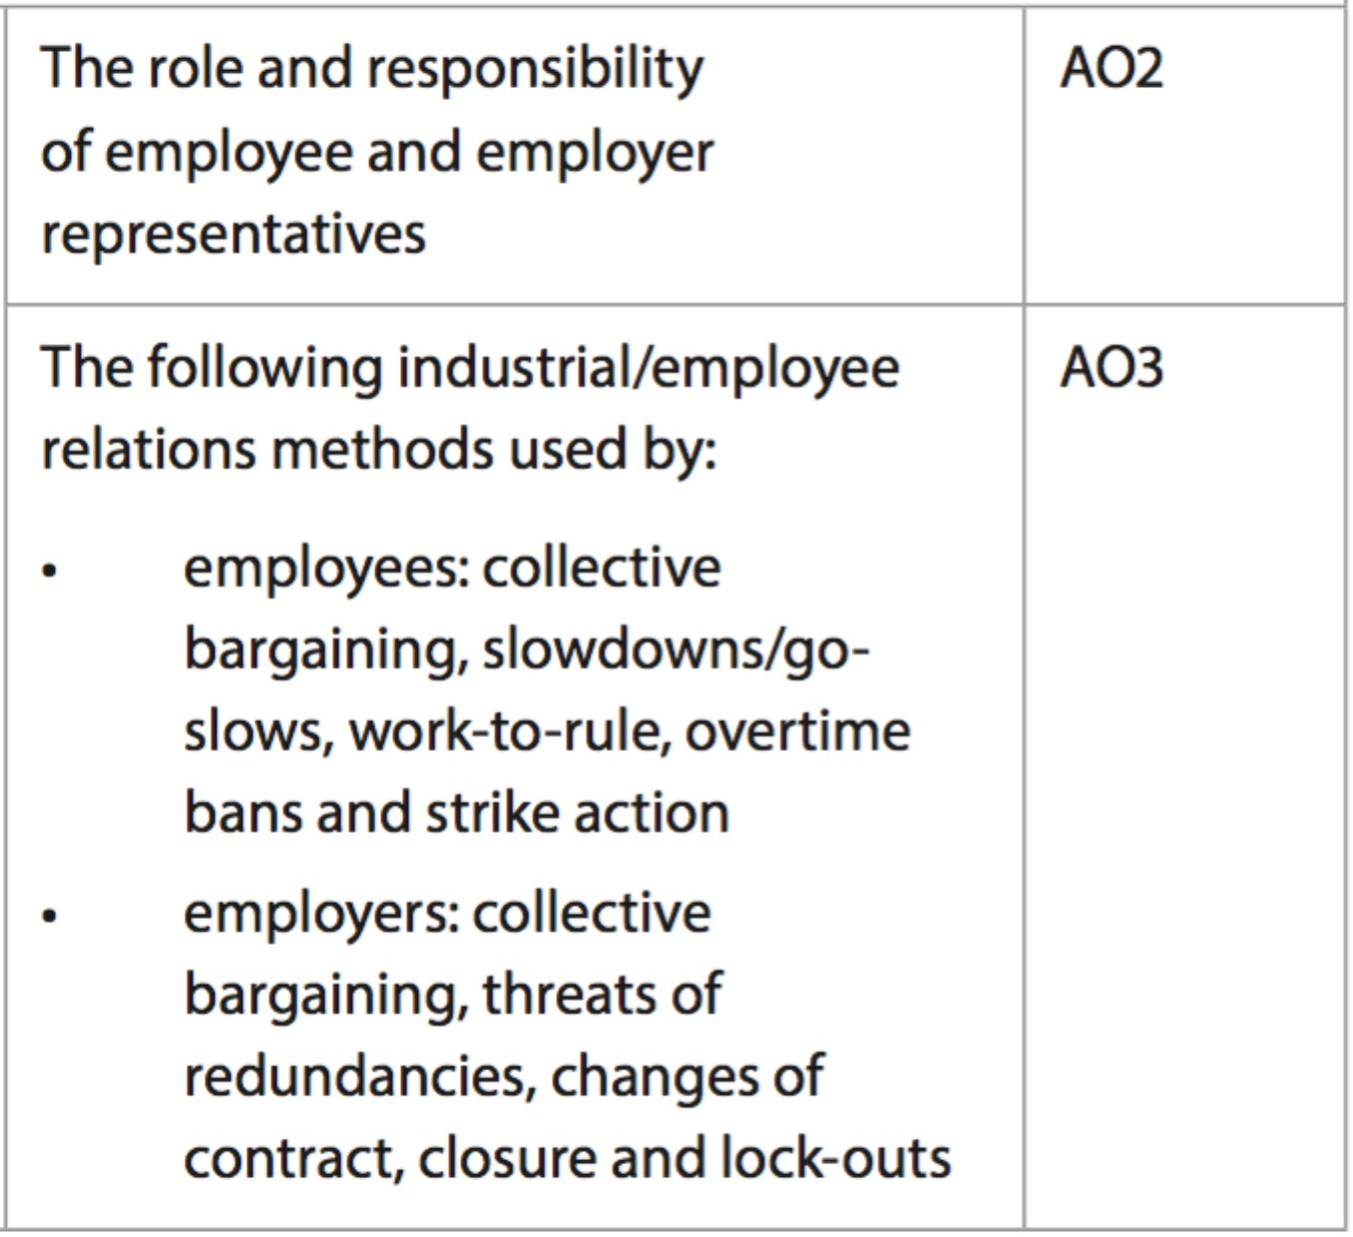

Know that **collective bargaining** (CBA) is the negotiation of wages and other conditions for a large group of employees. Trade unions represent employees during this process. Know that **slowdowns** are a method of protest whereby employees work as slow as possible, without breaching their employment contracts. Know that **work-to-rule** is a method of protest for employees, whereby each employee works entirely within their job description, as more often than not, employees complete extra duties in order to be productive. Know that **overtime bans** are a method of employee protest whereby all overtime work is turned down. This will reduce productivity of the employer, but result in lost income for the employee. Know that **strike action** is a method of protest whereby employees, collectively, refuse to work and protest actively to the employer. This also results in lost income and needs to be arranged legally (or is considered illegal in many countries). Know that **threats of redundancies** are used by employer representatives to mitigate employee actions, scaring employees to return to work or accept the employer demands. Know that **changes of contract** are another threat used by employer representatives, whereby full-time or part-time employees may be moved to casual contracts, reducing the number of hours worked and ultimately income. Know that closure and lock-outs are threats by employer representatives, whereby employees will be prevented from entering work, possibly permanently in the case of closure. This reduces employee payment, but also results in reduced productivity for the employer. Be able to combine and synthesize these ideas into a new idea and make a judgment based on the weight of evidence. E.g. in 2011, NBA players union and the owners/league could not meet each others demands for the CBA in time for the season. Owners locked players out of the clubs, denying access to facilities and staff, which forced the league to suspend the start of the season by 2 months. This led to a reduction in ticket sales, tv advertising revenue and the cities also lost tourist revenue. Eventually, both parties negotiated an and the lock-out ended.

Know that change, different interests and values, lack of resources, poor communication and performance can bring about conflict in the workplace. External factors also play an important role, and may be outside anyone’s control. Be able to break concepts down into individual characteristics and see the broader picture how they relate E.g. Poor communication can fuel internal rumour and politics within an organization to fill the information vacuum. Rumour and politics create misinformation and conflict often occurs.



Know that conciliation aims to resolve conflict by using an independent 3rd party to help each side come to an agreement, with arbitration resulting each side cannot reach agreement and the 3rd party making a decision. Know that employee participation is an example of industrial democracy, whereby employees are more involved in the negotiation process. Know that employers input no-strike agreements into contracts/CBAs in order to remove this option of protest from employees, often at the expense of providing more favourable conditions elsewhere in the CBA. Know that employers may enforce single-union agreements, whereby all employees are represented by only one trade union in order to simplify negotiation. Be able to combine and synthesize these ideas into a new idea and make a judgment based on the weight of evidence. E.g. QANTAS went to arbitration with the Transport Workers Union over the breakdown of negotiations in the collective bargaining process. Fair Work Australia, the independent arbitrator, decided in favour of QANTAS, meaning that their terms of the negotiation were met. The drawn out process, including strike action, cost QANTAS $68 million and the cancellation of 600 flights; however, the labour cost increases could have been significantly higher



Know that many employees, despite some perceived inequity, may be resistant to change in the workplace due to self-interest (does it benefit them?), low tolerance (lack of flexibility, and possibly fear), misinformation (uncertainty about what is actually happening) or interpretation of circumstances (one’s own perspective of the situation). Be able to break concepts down into individual characteristics and see the broader picture how they relate E.g. a younger (and possibly lower level) employee represented by the same trade union as an older (and possibly more experienced) employee may see CBA negotiation as less important to them. The younger employee may be more focused on job security and proving themselves capable, with a lower tolerance for change. An older employee may have more financial obligations and require increasing pay and conditions to be more financially secure. In this case, the younger employee is more likely to resist change than the older employee

Know that innovation has improved er/ee relations via improved communication technologies between employees, their representatives and employers; however, misinformation may be falsely spread on social media. Know that ethics and trust are important in the process, as trade unions need to represent the employees fairly to get the best deal, yet not put the jobs of the employees in danger through threats of redundancies. Employers also have obligations towards employees in areas of safety and work conditions. Also know that culture, both organizational and national, play important roles. In some countries, strike action is illegal partially or altogether. Be able to combine and synthesize these ideas into a new idea and make a judgment based on the weight of evidence. E.g. Police and sometimes teachers in the US are prevented from striking due to the essential services they provide. At the same time, many teachers in the US are paid below average compared to other developed nations, with many US teachers choosing to work overseas or quitting the profession. Their inability to use strike action to increase salaries and conditions could be seen as hindering their cause. On the other hand, the French hold strike-action as a constitutional right, and are well known to use the method to solve industrial disputes. Whilst French workers are known to have enviable work conditions, productivity is often negatively affected.

**Example questions may include:**

Define the term *lock-outs*  [2 marks]

Distinguish between *conciliation and arbitration*  [4 marks]

Analyse two reasons why an employee will be resistant to change [6 marks]

Examine the advantages and disadvantages of strike action for the employees [10 marks]

Discuss the importance of human resource strategies in reducing resistance

to change [10 marks]

Know that HR departments need to manage change using strategies, in order to reduce resistance to the change, such as getting agreement from employees early, having a clear timetable and communicating to employees and their representatives. Be able to combine and synthesize these ideas into a new idea and make a judgment based on the weight of evidence. E.g. McDonald’s launched all-day breakfast in Australia with little thought for the increased workload for staff. The work has become more complex, work conditions are more cramped and managers are placing more pressure on workers to maintain fast service times. Employees have taken to Reddit to complain as McDonald’s states publicly their crew has welcomed the change. Of course, employees had little to do with the change, with teenage high school employees impacted most as it is during their shifts that the change is occurring.