**Unit 1.5 External Environment**

**Syllabus Objectives**



Know the STEEPLE (Social, Technological, Economic, Environmental, Political, Legal and Ethical) external factors that provide opportunities and threats to businesses. Be able to break concepts down into individual characteristics and see the broader picture how they relate. E.g. Changes in the economy, such as economic growth, increases in employment or rises in the value of a currency may require to social changes, such as an adoption of luxury western products and lifestyles. This may provide new opportunities for modern businesses while threatening more traditional businesses.

Also, you need to be able to prepare a STEEPLE analysis for a specific business – identifying and explaining the external opportunities and threats within this framework

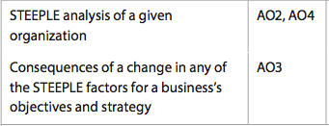

Know that changes in the external environment may not just impact on a business financially, but it may also require the business to reconsider its objectives and strategies to remain viable. Be able to combine and synthesize these ideas into a new idea and make a judgment based on the weight of evidence. E.g. Societies expectations over time have changed towards greater demand for environmentally friendly business practices. Companies operating in many industries that previously caused harm to the environment have had to change their goals in respect to this social change. The same is for child labour/ethics and changes in technology. These changes may require changes in marketing strategy and new employees and managers who can follow through with more modern business practices.

**Example questions may include:**

Prepare the Political and Economic parts of a STEEPLE analysis for company X [6 marks]

Analyze the impact of high unemployment and an aging population on the

objectives of Doctors Without Borders [6 marks]

Discuss how rapid technological advancement can be an opportunity and a

threat to Apple [10 marks]