**Unit 2.5 Organisational (Corporate) Culture (HL only)**

**Syllabus Objectives**

Know the definition of organizational (corporate) culture. Be able to describe an organisation’s culture from a situation. E.g. Google is seen to have a culture of fun and happiness as well as a high level of diversity and openness with fewer formalities between different levels of hierarchy

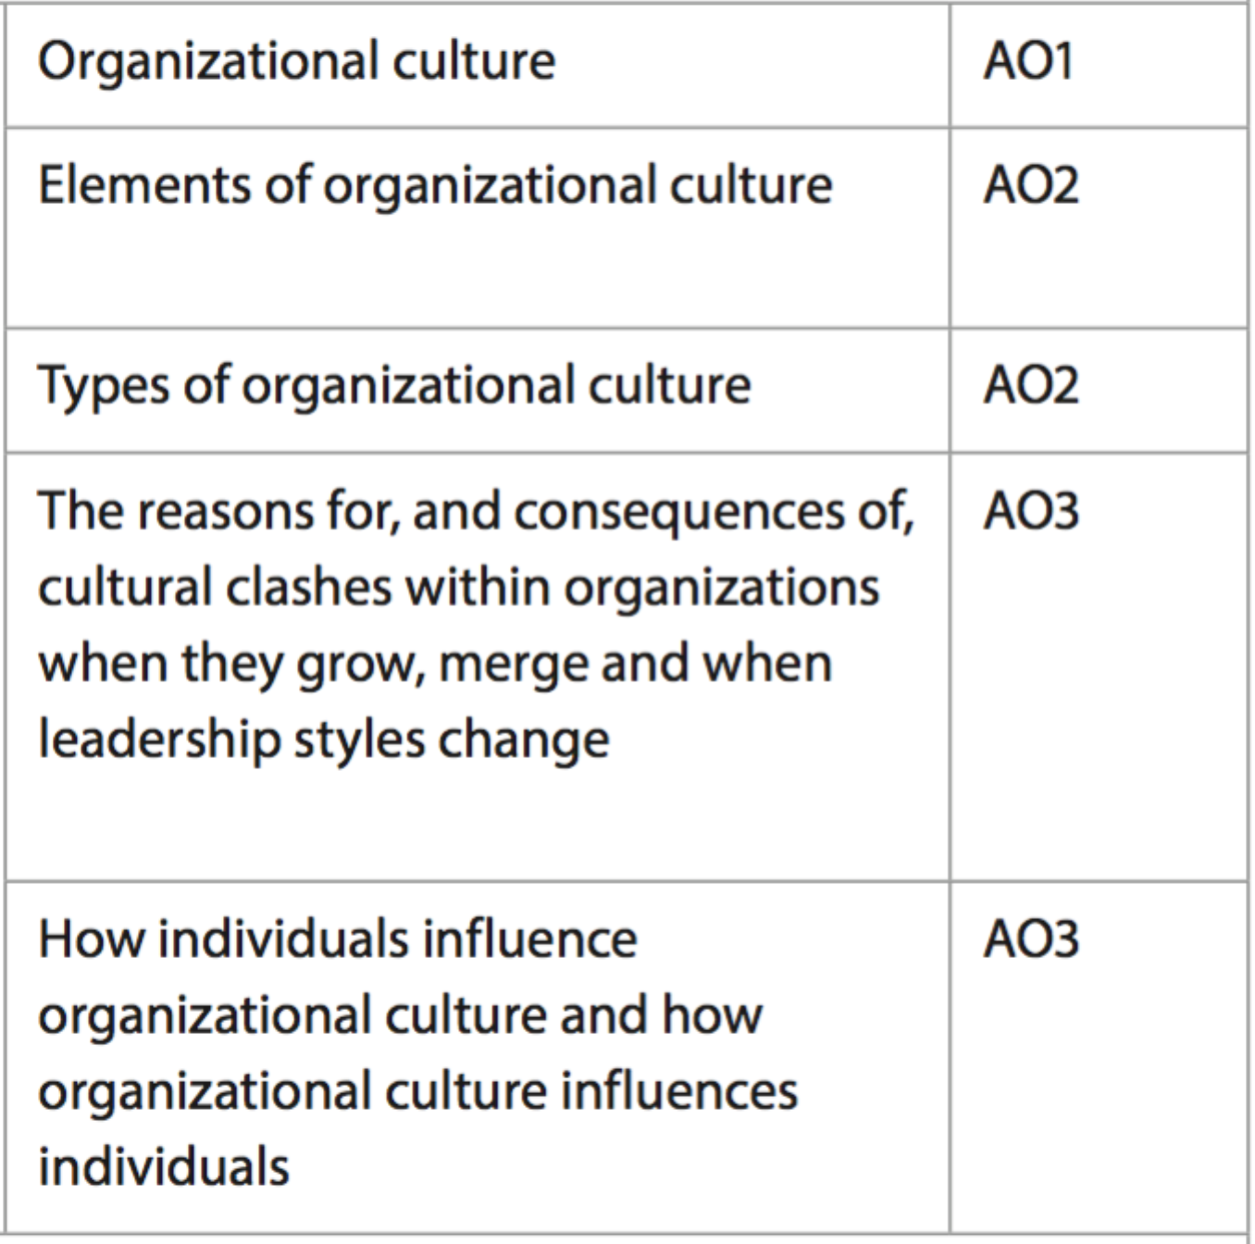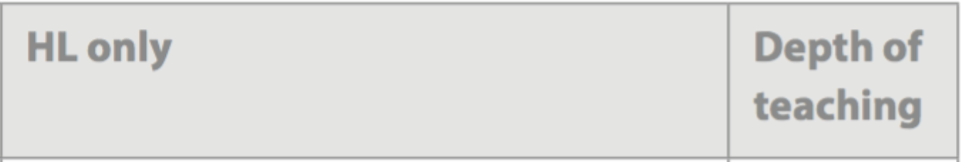

Know the elements of organizational culture include the norms, values, beliefs and attitudes that define what behaviour expectations exist for employees. Be able to break concepts down into individual characteristics and see the broader picture how they relate E.g. organisations that have a culture of autonomy, whereby the freedom to achieve goals in a number of ways is valued, then employees may have access to social media on their work device. However, if management adopts an autocratic style of leading, such freedoms are more likely to be restricted.

Know that the types of organizational culture, according to Handy, include task, role, power and person cultures. Hofstede uses power distance, individualism vs collectivism, masculinity vs femininity, uncertainty avoidance and short vs long term. Be able to break concepts down into individual characteristics and see the broader picture how they relate E.g. Organisations with power cultures (Handy) or masculinity (Hofstede) are more competitive and reward results, not processes. These cultures are appropriate in some high pressure, high reward industries. However, some of the biggest failures in business, such as Enron, were too focused on the results and overlooked the unethical or illegal methods employees used to achieve their results

Know that when organisations merge, each organization is likely to have a different culture based on the organizational structure, types of rewards offered to employees, degree of formality, leadership styles and the value of time and urgency to name a few. There is also likely to be conflict due to the merging of positions. Leadership change can occur at any time, and different leadership styles will often lead to different norms and values within the business. Be able to combine and synthesize these ideas into a new idea and make a judgment based on the weight of evidence. E.g. AOL and Time Warner merged in 2001, which is considered one of the worst mergers in history. Central to the failure was culture clash, with both organisations having different leadership styles. TW was considered genteel and polite, AOL was considered arrogant and a bully. TW provided its employees a more executive experience and rewarded them for what they know, whereas AOL employees travelled cheaply and were rewarded for being entrepreneurial and creating new ideas. The clash led to confusion amongst advertisers about which company they were dealing with, but more importantly, confused employees about which leaders they were reporting to. The 2 businesses split a few years later, with TW now to be acquired by AT&T



Know that organizational culture influences individuals, especially in the early phases of their employment, as employees are more likely to fall in line with the accepted norms and rules their colleagues follow. High functioning, inspirational and motivational workplaces will often attract more talented recruits that already exhibit many of the traits the organization seeks. This makes for minimal adjustment by the employee. Know that individuals influence the culture of an organization by taking a lead and seeking followers to shape the desired set of norms and rules. This is more likely to happen in dysfunctional corporate cultures, whereby employees or leaders are unable to obtain motivation, or whereby the current culture of the organization is detrimental to the organization reaching its desired goals. Be able to combine and synthesize these ideas into a new idea and make a judgment based on the weight of evidence. E.g. The Mayor of Madinah in Saudi Arabia instructed all employees to touch in fingerprints 5 times per day to improve punctuality. The culture of municipality staff was so poor that 68% of employees regularly took 3-hour breaks, 59% left well before time and 69% were regularly absent without an excuse. The culture had led to only 25% productivity amongst employees. The mayor is trying to influence the culture with this new measure, hoping that improved punctuality will result in improved productivity, however, he has faced severe backlashed, booed by his staff who considered it childish and imprisonment. Many argue that managers are equally absent and it is their responsibility to oversee the actions of employees, not fingerprint scanners.

**Example questions may include:**

Define the term *organizational culture*  [2 marks]

Explain two elements of organizational culture [4 marks]

Distinguish between two types of organizational culture [6 marks]

Discuss whether the change of leadership at Apple led to cultural clash [10 marks]

To what extent have individuals influenced the organizational culture at Google [10 marks]