EMMIs Chai Latte

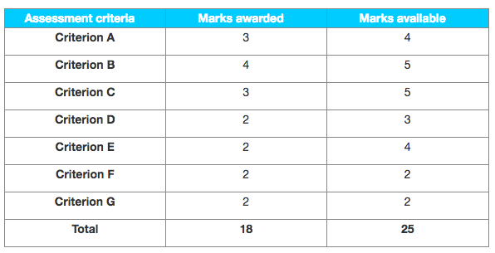

Examiner comments

With a mark of 18, this SL IA is a level 6; it is really good but for a level 7 some gaps should have been avoided, notably providing (financial, quantitative) evidence of the business growth (as implied by the research question).

Criterion A – Supporting documents

Three suporting documents meeting the time frame; relevant sections were translated (for example see pages 9 and 10).

Criterion B – Choice and application of tools, techniques and theories

The tools, theories and techniques are suitably applied, with correct use of subject terminology (internal growth, product portfolio, niche market, Ansoff for product development, cannibalism, etc). 4 marks is “best fit” as the commentary needed to address the latter part of the research question about “impact on the business in terms of growth” for top band; this phrase would imply financial calculations.

Criterion C – Use and analysis of data and integration of ideas

Simple, straightforward analysis in response to the research question; having more supporting documents with financial information may have helped score higher. 3 marks is “best fit” again as the analysis is “satisfactory”.

Criterion D – Conclusions

The conclusion page 5 needed more to support the judgement (the “seems to have had a positive effect” becomes “undeniably positive”, this was not really shown in the commentary); adding new information in the conclusion (for example about external growth and the planned conglomeration with Kaiku) can be confusing and should be avoided.

Criterion E – Evaluation

Some of the judgements are substantiated, for example about the Ansoff matrix (page 4) but the candidate never really shows the positive impact in terms of growth (although they just kept restating it).

Criterion F – Structure

The structure is appropriate and quite easy to follow.

Criterion G – Presentation

Very well presented (see footnotes); minor points could have been better (for example some missing page numbers and the whole page 6 is left blank) however overall the presentation is worth 2 marks, not 1.