## How Tesla-Toyota Project Led to Culture Clash by Opposites: Cars

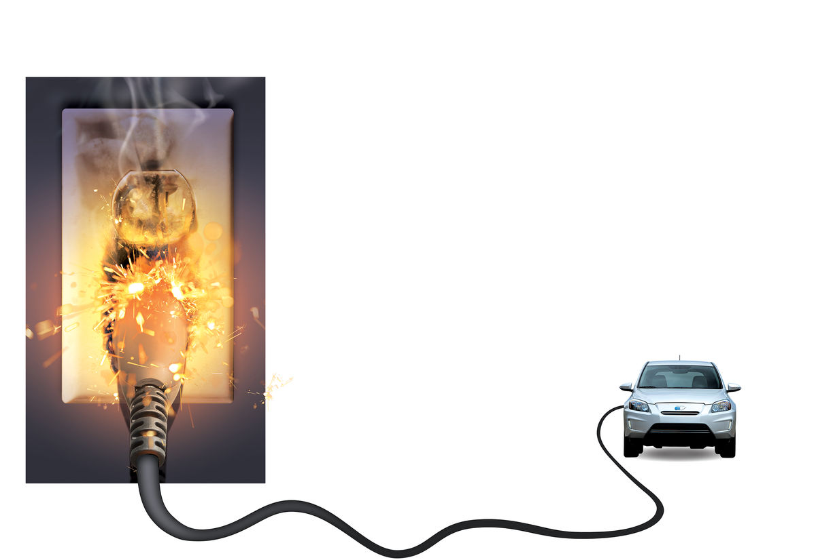In 2010, Tesla Motors Inc. Chairman Elon Musk invited Akio Toyoda, president of the world’s biggest automaker to his home. The two hit it off so quickly that within weeks, Toyota Motor Corp. agreed to buy a $50 million stake in Tesla and sold a modern California factory to its new partner for only $42 million. They also agreed to retrofit the Toyota RAV4 utility vehicle and considered extending the collaboration to an electric Lexus RX SUV.

In 2014, the ties unraveled as sales of the co-developed RAV4 electric vehicle wound down, with fewer than 2,000 deliveries to date. Once lauded by Musk as a springboard for a deeper partnership, the SUV stood little chance of becoming a hit after Toyota slapped it with a sellling price of almost $50,000 -- double the gasoline version -- and limited its availability to California.

The alliance was marred by clashes between engineers and highlights how quickly marriages of convenience can turn sour in the auto industry. Toyota then distanced itself from Tesla’s core electric vehicle market and embraced fuel cells, a technology Musk ridicules.

“Just because two companies are successful doesn’t mean when they come together, they will succeed,” said [Ashvin Chotai](http://search.bloomberg.com/search?q=Ashvin%20Chotai&site=wnews&client=wnews&proxystylesheet=wnews&output=xml_no_dtd&ie=UTF-8&oe=UTF-8&filter=p&getfields=wnnis&sort=date:D:S:d1&partialfields=-wnnis:NOAVSYND&lr=-lang_ja), managing director of Intelligence Automotive Asia. “When you’ve got somebody threatening the status quo in an industry and they try to cooperate with the biggest player, it’s bound to lead to so many complexities.”

At first the CEO of Tesla called the alliance “historic” and said Toyota was a company he long admired. In describing his test drive of the Tesla Roadster about a month earlier, Toyoda said he felt “the wind of the future.”

For Tesla, the deal meant money, its first factory at a bargain price, and the credibility that comes with working alongside an industry leader.

For Toyota, the alliance gave the grandson of the company’s founder the opportunity to reinvigorate a carmaker reeling from it’s a product recall crisis. Toyota’s investment also ended up being a profitable one: its [Tesla stake](http://www.bloomberg.com/quote/TSLA:US) grew to be worth more than $700 million.

“When Akio got involved in this with Elon, I think it went beyond batteries,” [Jim Lentz](http://search.bloomberg.com/search?q=Jim%20Lentz&site=wnews&client=wnews&proxystylesheet=wnews&output=xml_no_dtd&ie=UTF-8&oe=UTF-8&filter=p&getfields=wnnis&sort=date:D:S:d1&partialfields=-wnnis:NOAVSYND&lr=-lang_ja), head of Toyota’s North American operations, said in May. “It was about teaming up with this very entrepreneurial, small startup in the automobile business.”

Tesla values the “world-class” production quality processes it learned from working with the Toyota.

“You had a case of two very different companies with different approaches,” said [John Hanson](http://search.bloomberg.com/search?q=John%20Hanson&site=wnews&client=wnews&proxystylesheet=wnews&output=xml_no_dtd&ie=UTF-8&oe=UTF-8&filter=p&getfields=wnnis&sort=date:D:S:d1&partialfields=-wnnis:NOAVSYND&lr=-lang_ja), a Toyota spokesman. “Sure, it was a difficult project, but it also had a very tight time deadline and the product came out on schedule.”

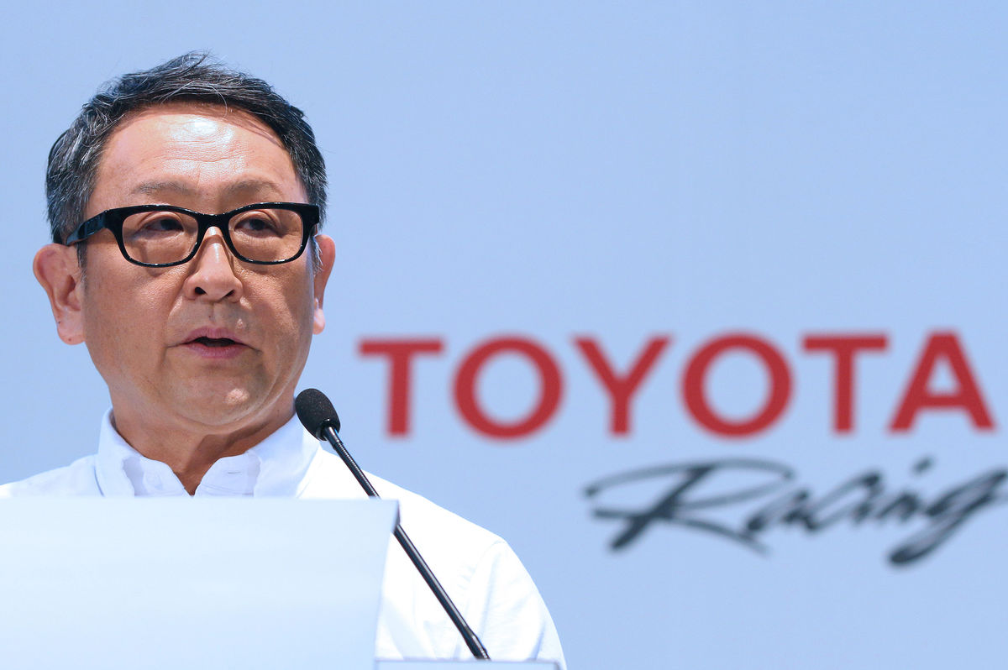Two years after Toyota and Musk announced the project, the RAV4 EV went on sale in 2012 -- fast for an industry where redesigning models can take seven years. Since then, deliveries of the vehicle have totaled 1,902 through July.

Tony Williams, who bought the vehicle in November 2012, said his RAV4 EV has spent more than 30 days getting repairs and has needed replacements for the motor assembly, heater and power electric-power converter. Williams still drives electric, though he prefers to do so in a [Nissan Motor Co.](http://www.bloomberg.com/quote/7201:JT) Leaf instead.

“The two automakers are diametrically opposed in so many ways,” said [Ed Kim](http://search.bloomberg.com/search?q=Ed%20Kim&site=wnews&client=wnews&proxystylesheet=wnews&output=xml_no_dtd&ie=UTF-8&oe=UTF-8&filter=p&getfields=wnnis&sort=date:D:S:d1&partialfields=-wnnis:NOAVSYND&lr=-lang_ja), an industry analyst for researcher AutoPacific Inc. “I don’t see Toyoda working with Tesla again just because EVs aren’t where their heads are at.”

In 2017, Toyota sold all of its share in Tesla, formally ending their relationship

1. Define the term *organizational culture* [2]
2. Analyse 2 reasons why Toyota and Tesla experienced culture clash [6]
3. Discuss the consequences of culture clash to business collaborations, such as Toyota and Tesla, [10]