JING SI WAN

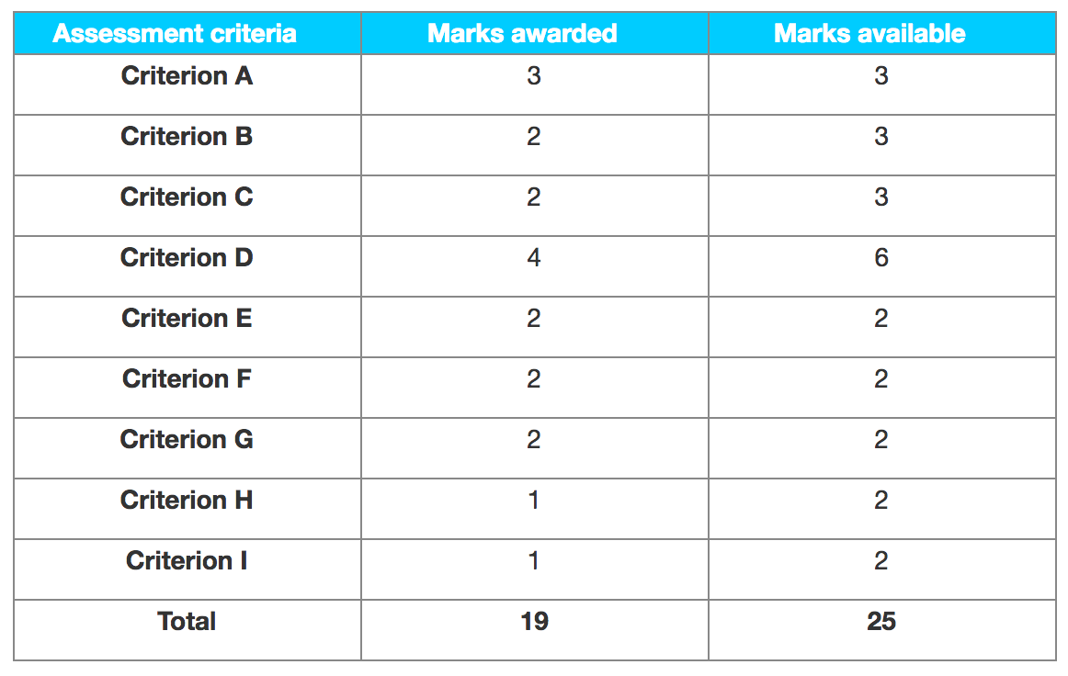

Examiner comments

Criterion A – Research proposal

Best fit is 3 marks. The research proposal has all the required elements and these are just sufficiently detailed, clear and focused.

Criterion B – Sources used and data collected

This does have evidence of a questionnaire set for employees. Appendix 2, a set of graphs from the questionnaire results, was not regarded as a source document. The third appendix is a table showing employee turnover rate. The primary sources selected and the data collected are appropriate, but are not varied and sufficient.

Best fit is 2 marks.

Criterion C – Use of tools, techniques and theories

The candidate has used and applied at a satisfactory level Maslow and John Adam’s motivation theories. In addition, there is some discussion of leadership styles.

Criterion D – Analysis and evaluation

There is a satisfactory analysis of the results, using graphs with comments on the results. There was some integration of ideas where suggested solutions referred back to issues from the employee survey. Very limited evidence of evaluation places this at the 3 to 4 boundary.

Best fit is 4 marks.

Criterion E – Conclusions

The conclusions are quite detailed and clearly refer back to the data collected in the body of the report. They are therefore substantiated and consistent with the evidence presented.

Criterion F – Recommendations

While there is no separate recommendation section, the candidate has made their recommendations on pages 10, 11, 15 and 16 in the body of the report. These are detailed, substantiated and consistent with the conclusions.

Criterion G – Structure

The candidate has organized ideas into a structured report with an argument that is easy to follow. The placing of recommendations in the wrong position within the report is penalized under criterion H.

Criterion H – Presentation

No introduction page to demonstrate some background knowledge about the organization. The final section should be conclusion and recommendations, not just conclusions, and as mentioned in F above the recommendations were in the wrong section of the report.

Criterion I – Reflective thinking

The final paragraph of the report on page 16 is the only example of reflective thinking on the approach taken in this piece of research and its limitations. Best fit is 1 mark