**Unit 3.7 Cash Flow**

Know that profit includes revenue that is yet to be received by the business, meaning that a business that is profitable may have cash flow problems whilst it waits for its debtors to pay them. Be able to break concepts down into individual characteristics and see the broader picture how they relate. E.g. To build a new house may take a few months and the building company has already recorded the construction as a sale in their accounts. However, the owner may not pay for the total price until after the house is constructed. Meanwhile, the builder needs to pay for the materials, labour and permits to build the house until then.

**Syllabus Objectives**



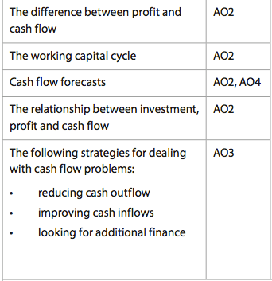

Know that it is important for a business to manage cash inflows together with cash outflows to reduce the reliance on external sources of cash. Be able to break concepts down into individual characteristics and see the broader picture how they relate. E.g. If the business is able to encourage debtors to pay earlier and not pay creditors until the last opportunity, this will shorten the time between cash outflow and inflow. At the same time, the business does not want to damage relationships with customers or suppliers by annoying them or paying late.

Know that cash flow forecasts are used to determine the future cash position of the business and are based on estimated information. Be able to break concepts down into individual characteristics and see the broader picture how they relate. E.g. If the cash flow forecast demonstrated a negative or declining closing balance, comment on the possibility of the business suffering a cash flow problem. At the same time, consider the size of the decline and whether there is a cycle to the ups and downs, as well as if this can be attributed to it being a new business. Also be able to prepare a cash flow forecast.



Know that without investment from internal or external sources, profitability and cash flow are unlikely to grow/improve. Be able to break concepts down into individual characteristics and see the broader picture how they relate. E.g. If the business has the choice of paying out a dividend or keeping the retained profits it needs to consider future profitability and cash flow. Paying out dividends reduces cash and therefore limits the ability of the business to pay its creditors on time. At the same time, businesses need to continually invest in new assets to be profitable.

**Example questions may include:**

Define the term *Working capital cycle*  [2 marks]

Distinguish between a cash flow and profit [4 marks]

Prepare a cash flow forecast for 6 months for Company X [6 marks]

Evaluate whether the business should consider debt factoring or selling dormant

assets to improve its working capital [10 marks]

Know that businesses should aim to use these strategies above, as well as the implication on other parts of the business of using each (or a combination of) the strategies. Be able to combine and synthesize these ideas into a new idea and make a judgment based on the weight of evidence E.g. To improve cash flow, a business may reduce it spending on marketing. At the same time, a reduction in marketing may reduce market share, resulting in a decline in revenue and cash inflows in the longer term. The business may seek to obtain an overdraft to overcome short-term cash flow problems, however this will come with a higher level of interest payments that may create future cash flow problems.