# Black Lives Matter: The social media behind a movement

# *Posts with feelings of sadness more likely to spur people into action over Black Lives Matter, study says*

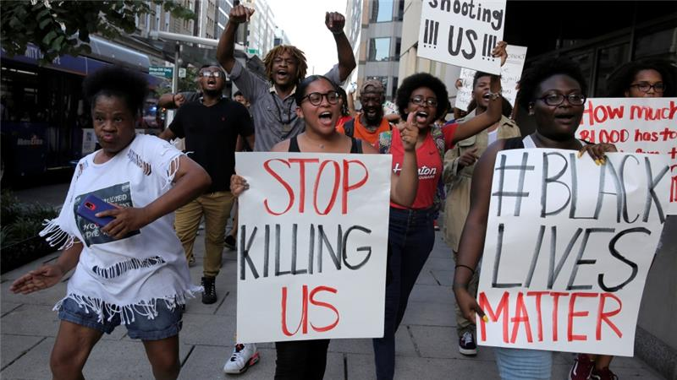By Anealla Safdar

3 August 2016

Tweets related to the Black Lives Matter movement suggest that sadness, rather than anger, might be more effective in galvanising people into action, according to new research.

Scientists analysed the emotions behind almost 29 million tweets about four events in 2014 and 2015 that led to Black Lives Matter (BLM) protests in an attempt to identify patterns.

Tweets with a higher level of "negative effect" and sadness, but lower on anger and anxiety were associated with larger rallies the following day, researchers at the Georgia Institute of Technology and the Qatar Computing Research Institute (QCRI) said.

Over time, people changed their posting style, using fewer negative references such as "death", instead opting for more social words such as "we" and "us".

"We did expect the tweet volume to be predictive of protest volume and it was interesting to see that collective emotions play an important role as well," said co-author Ingmar Weber, from QCRI, which is part of the Hamad bin Khalifa University. "However, we can't say that emotions alone lead to bigger protests as there may be numerous other factors causing them."

People from states with historically high rates of police violence against black Americans were more likely to use negative language, such as words relating to death, even if their state was not the scene of protests.

The research comes as the Black Lives Matter movement gathers pace. A coalition of organisers released on Monday an official policy agenda, calling for an end to the "war on black people", reparations, economic justice, community control, political power and investments in their safety.

"Social media has been critical in the knitting together of a national narrative of police violence and abuse," Keeanga-Yamahtta Taylor, a professor in African American studies at Princeton University, told Al Jazeera.

"Before, these incidents were depicted as isolated and individual. Social media platforms have shown how they are part of a generalised and pervasive pattern of police abuse."

She added that social media platforms had helped organisers to "overcome distance and geography by putting people in immediate touch with each other".

Adapted from: <http://www.aljazeera.com/news/2016/08/black-lives-matter-social-media-movement-160803042719539.html>

**Woman Calmly Facing Off Against Policemen at Black Lives Matter Protest**

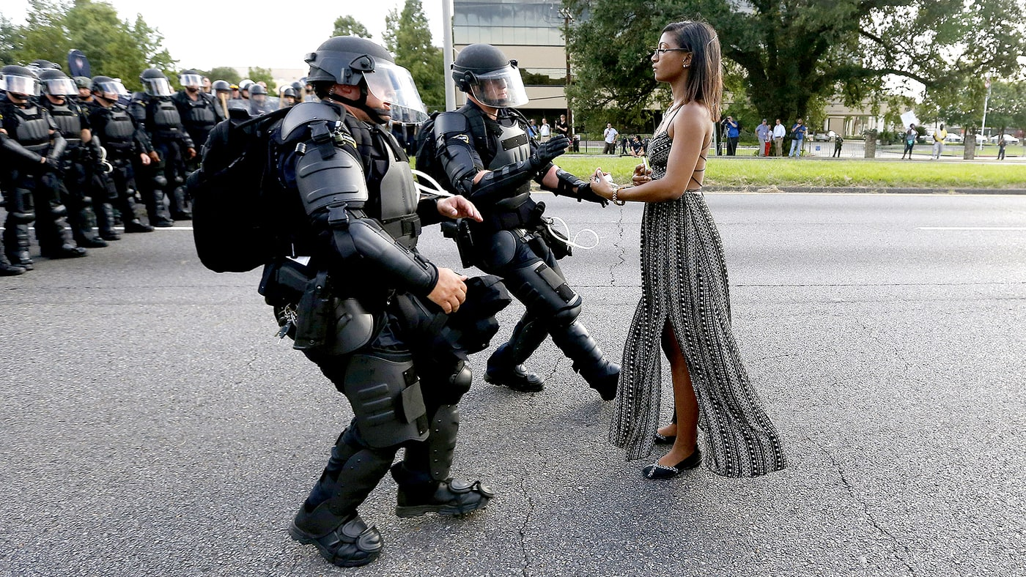Calm at the center of the storm. The woman peacefully facing off against policemen at a Saturday, July 9, Black Lives Matter protest in Baton Rouge, Louisiana.

Although it was a peaceful demonstration, held in the wake of the death of Alton Sterling, who was shot and killed by police on July 5 — many protesters, including Ieshia Evans (pictured), were detained by policemen. She was photographed calmly standing in front of two officers clad in riot gear who appeared to be charging at her.

Adapted from: <http://www.usmagazine.com/celebrity-news/news/woman-calmly-protesting-at-black-lives-matter-rally-identified-w212576>

**Corporations should not commercialize social justice issues**

**By Maris Medina**

**Published April 13 at 9:37 PM**

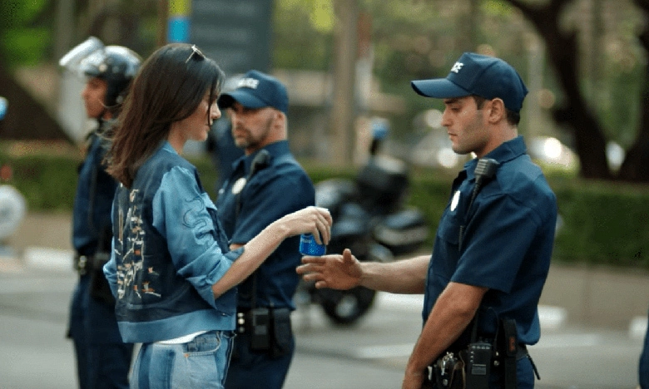

In the infamous Pepsi commercial that aired last week, a jaw-droppingly beautiful Kendall Jenner struts out onto the pavement — Pepsi can in hand — ready to defy the police who have lined up against a massive crowd of protesters. Epic music halts. Jenner approaches police officer. Jenner hands can of Pepsi to officer. Officer smiles. It appears as if Jenner and her fellow protesters have won. All thanks to Pepsi.

Of course, the commercial received a flood of backlash on social media and even major newspapers. It's not misguided for large multi-billion dollar companies to advocate for social justice issues (take Always' Like a Girl and Dove's Real Beauty campaigns for example) because they are using well-known platforms to bring to light pertinent problems in society. However, when these businesses use social justice issues as mere monetary strategy, that is where the line should be drawn. With our Pepsi commercial, entire scores of modern day movements — Black Lives Matter, women's marches and advocacy for Muslim tolerance — were immensely trivialized in the matter of two minutes.

For one, the idea that Pepsi can cure our society of its present inequalities was completely misdirected. And using a white supermodel among a backdrop of minorities only emphasizes the idea of the white man's burden. Pepsi's marketing team can insert the most motivating, empowering song and add in a woman photographer wearing a hijab all it wants, but this commercial only reinforced that 1) white people can solve everything 2) minorities will always be in the background 3) our world is driven by an unquenchable (no pun intended) drive for money.

Issues involving race and gender equality are extremely multi-faceted. There is so much intersectionality involved with each social justice issue that big businesses cannot use extraordinarily simple solutions to pitch to our communities.

I applaud big corporations for taking a stand with these issues. It's a step in the right direction. But Pepsi's commercial trivialized critical social justice issues. And that's when we need to put our foot down.

Adapted from <http://www.dbknews.com/2017/04/14/pepsi-kendall-jenner-commerical-social-issues/>