**Unit 3.3 Break-Even Analysis**

Know that an individual product may contribute (Price – Variable Costs) a large amount per unit, such as the sale of a large diamond ring, but a less valuable product that sells many units may contribute more overall, such as Coca Cola. Also know that contribution does not include fixed costs, so contribution is NOT profit. Be able to break concepts down into individual characteristics and see the broader picture how they relate. E.g. If a cafe is reviewing its product range and analyzing the contribution, it may consider dropping tea for the reason that tea only contributes 1 dirham per cup, whereas cappuccino contributes 2 dirhams per cup. But if the café sells four times more tea than cappuccino, then it will contribute more in total to the fixed costs of the café.

**Syllabus Objectives**



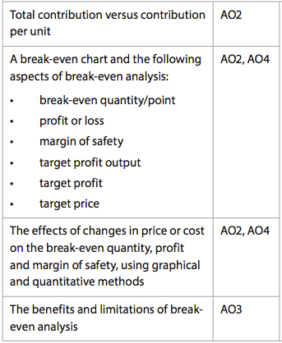

Know how to calculate break-even and to create the break-even chart **to scale**. Also know that when there is a target, this should be included in the break-even analysis. Be able to break concepts down into individual characteristics and see the broader picture how they relate. Also be able to make changes to the break-even when there is a change in the costs or price. E.g. An increase in price will likely decrease the break-even quantity as there will be a higher contribution per unit, however, this may reduce the demand for the product and the margin of safety may reduce even further, increasing the risk of the business not breaking even.

Know that whilst there are some advantages of using break-even analysis, there are several limitations to its usefulness and it should not be used alone but rather as one of a few analytical tools when planning and strategizing. Be able to combine and synthesize these ideas into a new idea and make a judgment based on the weight of evidence E.g. managers can use break-even as a simple calculation and that the chart provides a graphical image of the potential profits (or losses) the business can make beyond the break-even quantity. At the same time, break-even is only useful when analyzing one-product businesses. It also assumes that costs occur in a linear fashion, meaning the variable cost of producing one unit is the same as producing 100 units. It is also assumes that everything made will be sold, which may not actually happen. If the data is useful, the manager should use this tool but still weigh the results up against other quantitative and qualitative factors before making final decisions.

**Example questions may include:**

Define the term *margin of safety*  [2 marks]

Calculate the break-even quantity for Company Y [2 marks]

Prepare a fully labeled break-even chart for Company X [6 marks]

Calculate the effect on profit if there was a 10% increase in the price

following a 15% rise in variable costs, reducing demand by 5% [6 marks]

Evaluate the manager’s decision of not using break-even analysis as she says,

“it has too many limitations for our business needs” [10 marks]