**Unit 3.2 Costs and Revenues**

**Syllabus Objectives**



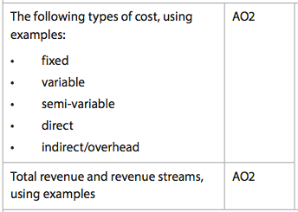

Know the different types of costs and how different function managers of the business use them (with examples). Be able to break concepts down into individual characteristics and see the broader picture how they relate. E.g. As a business increases its size and level of output (perhaps by opening a new factory), the fixed costs are likely to increase due to the new equipment, whereas the variable costs will hopefully reduce per unit. This is economies of scale, a key reason why businesses choose to grow.

Know that revenue is the money received by a business from selling its products. It can also be received as a financial benefit from other investments or from the sale of dormant assets if the selling price exceeds the balance sheet value. Also know how to calculate the total revenue and the various ways a business can receive revenue (do not confuse revenue with sources of finance). Be able to break concepts down into individual characteristics and see the broader picture how they relate. E.g. branding is important in order to access new revenue streams. Netflix began as a DVD distribution business, whereby customers could rent or purchase DVDs. As technology improved, Netflix was able to open up to online revenue streams in combination with the DVD business due to the confidence their subscribers had in the service. They have now ventured into making television programs such as House of Cards, opening another revenue stream.

**Example questions may include:**

Define the term *Revenue Stream*  [2 marks]

Distinguish between fixed costs and variable costs [6 marks]

Explain two costs to Company X as a result increasing production and new asset

Purchases [6 marks]