**Unit 5.5 Production planning (HL only)**

**Syllabus Objectives**

Know that supply chain management (logistics) refers to the organizing and controlling of the procurement of raw materials through to the delivery of the finished good to the customer. It can also extend to the procurement of raw materials of the suppliers. Be able to break concepts down into individual characteristics and see the broader picture how they relate. E.g. Kellogg’s uses Just-in-time inventory management system producing its breakfast cereals. They produce in a range of factories worldwide, and send products to distribution centres close by. From these warehouses, deliveries are sent to tertiary sector retailers in trucks that are shared with another manufacturer, Kimberly Clark, in order to reduce costs. As Kellogg’s do not sell directly to their consumer, they need to closely monitor sales trends to ensure enough supply to meet demand.

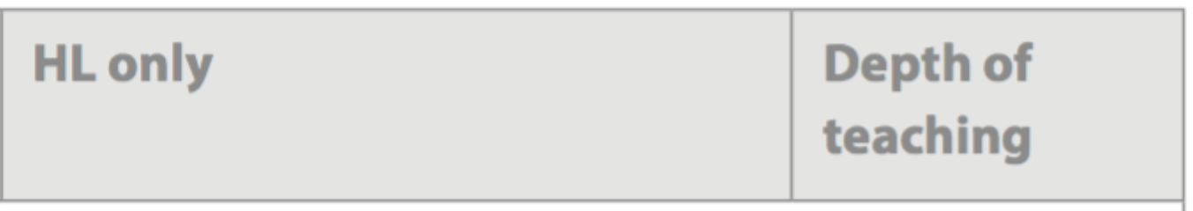

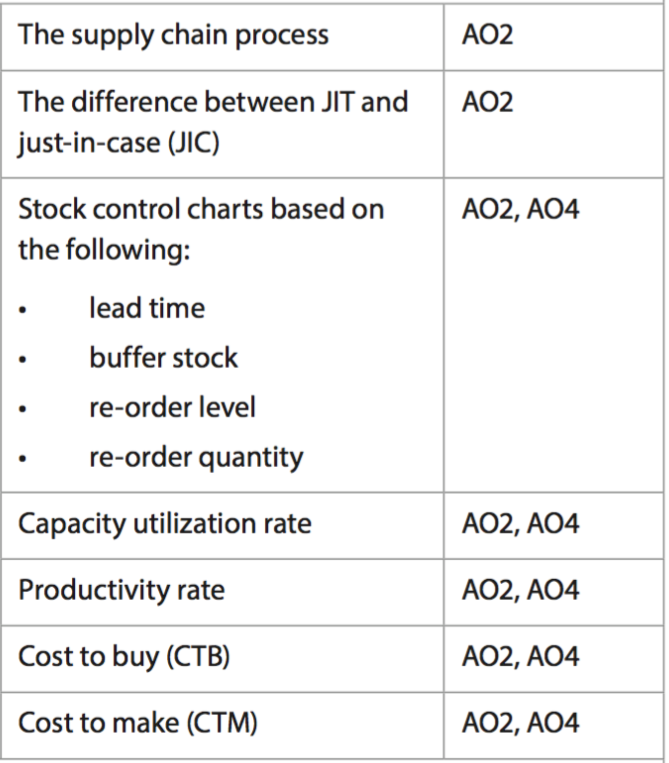

Know that just-in-case is a stock control system that requires stock to be delivered in advance and used when needed, whereas just-in-time is a stock control system that requires stock to be delivered at the time it is needed. Be able to break concepts down into individual characteristics and see the broader picture how they relate. E.g. Just-in-case stock control, for example the storing of car parts needed to build a car, requires parts to be stored, which requires space, electricity, security and insurance. Furthermore, it is assumed that all parts will be used to make cars in the future, which may not happen. On the other hand, just-in-time stock control means the parts are produced and delivered to the car factory at the time when they are needed. This reduces costs but requires significant planning, as a late delivery will cause a delay to the manufacturing of the cars.

Know that businesses (that require stock) cannot function properly if they do not maintain an optimum stock level. Too little and they are not able to produce their product, too much and there is excess storage and possible wastage. Be able to draw and analyse a fully labeled stock control chart E.g. A jewelry maker could choose to hold stock of gold, silver and precious stones using JIC, a higher buffer level than using JIT, as this would allow them to create almost any piece of jewelry at any time. It may also allow them to purchase the expensive stock when prices are lower, as they can fluctuate quickly and may have longer lead times than other industries. On the other hand, a florist will have much lower re-order levels, almost zero, due to the perishability of the product.

Know that a firm aims to operate as close to capacity as possible, however due to the 24-hour nature of many costs, absolute capacity might not always be possible. Also know that capacity utilization is calculated by (actual output / productive capacity x 100), so it is expressed as a percentage, with 100% representing maximum capacity. Be able to use quantitative and qualitative methods to determine the capacity of an organisation. E.g. A local restaurant can simply calculate the total capacity by the number of seats and tables that can be filled. However, these seats are not filled 24 hours a day. Furthermore, the manager could adjust the layout to include many more seats and less privacy in the restaurant. The productive capacity may not be the ultimate capacity, and qualitative factors need to be considered in determining what the productive capacity is.



Know that the graph and calculations used in break-even analysis are very similar to the quantitative methods used for make or buy decisions. The total costs curve (TC) represents the product being made (FC + (AVC x Q)), and the cost to buy is calculated by Price x Quantity. Both calculations and a graph can be used to work out if it is cheaper to make or buy a product. Also know that a range of qualitative factors, such as time, specialization, quality, capacity and more should also be considered in the decision. Be able to use quantitative and qualitative methods to determine whether the business should make or buy. E.g. LG manufacture refrigerators that come with a sparling water machine, and LG need to determine if it is better to make or buy this part. They need to consider the cost to do each, including any fixed and variable costs to make. Furthermore, LG need to know if they have the capacity to make it (factory, employees) and whether they can make it to the same quality as businesses that specialize in the production of these parts. All of these factors will help LG decide to make or buy it.

Know that productivity refers to the efficiency of a business, determined by dividing the level of output against a level of input, such as labour or machine hours. Know that this result is compared to industry benchmarks, forecasts or past results to determine the level of productivity. Be able to use quantitative and qualitative methods to determine the productivity of an organisation. E.g. A commercial printer prints 50,000 pages in 10 hours of running the printing machine (5,000 pages per hour). An upgrade of the machinery results in 120,000 pages printed in 16 hours (7,500 pages per hour). This demonstrates better productivity from the new equipment. However, the costs of this equipment and other factors are not considered, so a variety of analysis must be completed.

**Example questions may include:**

Define the term *productivity rate*  [2 marks]

Distinguish between *just-in-time and just-in-case*  [6 marks]

Analyse two problems with the stock control chart of company X [6 marks]

Calculate the CTB and CTM of product A [6 marks]

Explain two advantages of Company Y achieving a higher level of capacity [6 marks]