**Unit 3.1 Sources of Finance**

**Syllabus Objectives**

Know how to clearly define capital and revenue expenditure. Be able to break concepts down into individual characteristics and see the broader picture how they relate. E.g. A business needs to pay for both everyday costs to create revenue today and to invest in assets to create revenue in the future. Capital costs usually provide an asset that the business owns, whereas revenue expenditure is usually the payment of consumable things such as rent or wages that provide the business no asset of value.



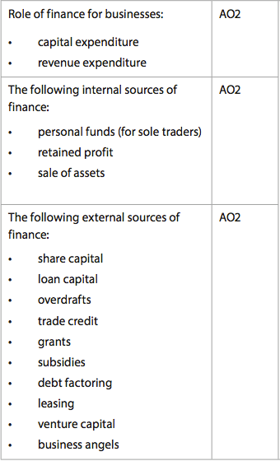

Know how to clearly define each external source of finance and that external sources of finance can provide large amounts of capital. Also know that deciding on a type, or combination of sources will depend on amount, time, risk, ownership, cost, purpose and other variables, and that most external sources come at a cost to the business. Be able to break concepts down into individual characteristics and see the broader picture how they relate. E.g. A business can raise share capital, but only if investors see value in the business (it needs to be of a certain size). Furthermore, the business owners are then giving up some ownership and profit share to raise the share capital. A business seeking smaller amounts of money, or are not as likely to raise share capital may seek venture capital from investors who see potential with limited proof. They are also likely to want ownership of the business, but are taking on a large risk by providing a large amount of money to an unproven business.

Know how to clearly define each internal source of finance, and that internal sources of finance, depending on the size of the organization, are less useful when larger amounts of investment are required. Be able to break concepts down into individual characteristics and see the broader picture how they relate. E.g. A business can sell its assets in order to raise finance, however this could be detrimental if the business still requires the asset to create revenue. It may be forced to sell the asset and receive the cash, but then need to continue leasing it in the future, which will be more expensive. Retained profits can also be used, but using all of it can be risky should the business suffer financial difficulty in the future.



Know that sources of finance can be classified as short, medium or long-term based on when they need to be repaid as well as the length of the benefit the finance will provide. Be able to classify, define and state these types of finance. E.g. Overdraft is a short form of a loan that provides short-term cash relief, for example, when wages need to be paid due to a delay in receiving payment from a customer. Loan Capital is more likely to be a long-term source of finance if it is used to purchase a large investment (like a factory) and be repaid in more than 5 years.

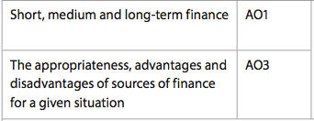

Know that each business situation requiring finance will have appropriate and inappropriate ways to finance it. Know especially that almost all business decisions will have a financial impact on the business, and it is important to know if there is an adequate way to finance the decision. Be able to combine and synthesize these ideas into a new idea and make a judgment based on the weight of evidence. E.g. A business is considering purchasing a new machine that will improve productivity in the factory. The business has enough retained profit to buy the machine, but is worried about using all their cash as this increases the risk of the business, even though there would be no interest to pay. They will be able to sell the existing old machine, but it will only raise about 20% of the money needed. Selling this machine is suitable as it will no longer be needed and has no extra costs. A loan could be used for the remaining 80%. This will incur interest charges, and the bank will use the machine as collateral, which means they can repossess it if the loan is not paid back. The business could also not purchase the machine at all, instead leasing it from the manufacturer. This will result in higher monthly charges than the cost to purchase it, however, a breakdown of the machine is the responsibility of the manufacturer and may have a lesser impact on productivity if breakdown occurs. The final decision will need to consider the openness to risk of the business as well as the length of time the asset will remain useful.

**Example questions may include:**

Define the term *Debt factoring*  [2 marks]

Identify 3 long-term sources of finance [3 marks]

Distinguish between *Revenue expenditure* and *Capital Expenditure* [6 marks]

Contrast business angels and venture capital [4 marks]

Analyse two benefits of raising share capital through an IPO [6 marks]

Discuss whether an overdraft or trade credit provide the most appropriate

Source of finance for company X [10 marks]