Atlassian IPO: the line in the prospectus everyone missed

Date: November 16, 2015

By: [**John McDuling**](http://www.smh.com.au/business/by/John-McDuling)

It takes a special kind of company to pledge a ["No Bulls*t" approach to business and tell staff  "Don't #@!% the Customer"](http://www.smh.com.au/business/markets/atlassian-ipo-everything-you-need-to-know-about-australias-software-darling-20151109-gkutf7.html) in its paperwork for a share market float.  And so it was with Australian software darling Atlassian, which made these statements in its long awaited US IPO prospectus last week.



Atlassian's corporate culture is getting a lot of attention, and fair enough. It is seen as a critical element of the software company's stunning success.

The decision to use a [News Corp style](http://www.afr.com/technology/atlassian-founders-to-keep-control-with-news-corp-style-structure-20151109-gkuswm) dual class share structure that will allow its founders to retain control once their company is listed [also raised eyebrows](http://www.smh.com.au/business/world-business/investors-look-past-dual-stock-structure-in-atlassian-float-20151110-gkv47r.html). Yet there was a much more significant line buried in the IPO filing last week that that everyone overlooked.

It tells you a lot about the company's philosophy and how it plans to continue its impressive growth streak.

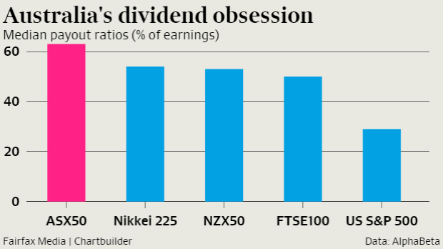*"We do not expect to declare dividends in the foreseeable future"*the line in question read.

It's not unusual for a technology company to say something like this. But it is unusual - highly unusual! - for an Australian company to say something like this. Because, in case you didn't notice, Australian companies and shareholders are quite obsessed with dividends. So much so that arguably, it is becoming a problem.

A telling statistic on Australia's dividend obsession comes from Andrew Charlton, a former adviser to Kevin Rudd who now runs consultancy AlphaBeta.

The 50 biggest companies on the ASX pay out 63¢ in every dollar of earnings to shareholders, he calculates, up 58 per cent from 40¢ a decade ago, and way ahead of the 50¢ average for companies in the UK FTSE and 29¢ for companies in the US S&P 500.

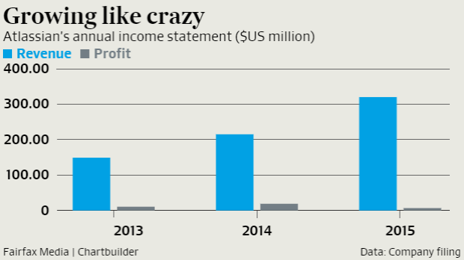It's explained, at least partially, by the dividend imputation system, which means company profits in this country, unlike many others, are not double taxed.

Dr Charlton [expressed concerns](http://www.afr.com/news/economy/alpha-betas-andrew-charlton-says-asx-dividend-trend-destroys-investment-ambition-20150727-gilc13) earlier this year that Australia could in fact be spiralling into a self-fulfilling "dividend doom loop", where the biggest companies don't invest (because they use all surplus capital for dividends) and ultimately can't grow.

Of course, Atlassian isn't targeting Australian investors with its IPO, that's why it's listing on NASDAQ, after all.

Yet, it's biggest office remains in Sydney, and it is quickly becoming one of the nation's most important companies. Australian investors can also buy US shares relatively easily these days. So Atlassian's anti-dividend stance is worth closer inspection.

There is a very simple explanation for the policy.

"We currently anticipate that we will retain future earnings for the development, operation and expansion of our business" Atlassian says in the filing.  Job outsourcing marketplace *Freelancer* made a similar pledge when it listed on the ASX in 2013.

What these companies are doing – using surplus cash to invest for growth rather than letting it flow to the bottom line – is not uncommon in Silicon Valley.

Amazon is one of the more prominent examples of a company pursuing this strategy. The e-commerce giant has achieved double digit growth in revenue for more than 50 straight quarters, but has generated negligible profits (and never paid a dividend) during that time, as it keeps the foot firmly on the accelerator pedal.

Amazon’s long-term shareholders don't seem to mind. The stock is up 39,000 per cent (!!!) since its 1997 IPO. Amazon hasn't had to raise any additional equity finance since then, although it has taken on debt.

Whether Atlassian follows an extreme path like this remains to be seen, but it is clear the company sees a lot of growth ahead of it. It currently has 5 million monthly active users of its software, but has ambitions to grow that to 100 million in the next 13 years.

It will no doubt face challenges along the way. At the moment, just 25 per cent of its revenue comes from its cloud based offerings – most of its customers still used installed on premise software.  The unstoppable shift to the cloud will require substantial investment. The company's astonishing track record of self-financed growth while maintaining profit should hold it in good stead on this journey.

But it also means dividends are out of the question, which is a refreshing antidote to prevailing attitudes in Australia  
  
Source: <http://www.smh.com.au/business/markets/atlassian-ipo-the-line-in-the-prospectus-everyone-missed-20151115-gkzp0w.html#ixzz3uEBgUZen> 

**Vocabulary List**

**Sharemarket float** – same as an IPO or ‘going public’. Becoming a publicly traded company on a stock exchange.

**Corporate culture –** the way employees interact and complete work based on leadership traits and philosophies.

**Dual class share structure** – the original owners will own shares with different voting rights and profits than ordinary share holders

**ASX –** Australian Stock Exchange

**UK FTSE** – UK Financial Times Stock Exchange, and index of the UK’s top 100 companies

**US S&P 500** – An index of the 500 top US companies

**NASDAQ** – A US Stock exchange, the first to run electronically, so is often used by tech companies.

Sample questions and answers – Atlassian.

**1. Define the *shareholders***  [2 marks]

Shareholders are the people that hold the shares, often in a company. The shareholders spend lots of money to buy them, but can make a lot of money from owning and holding the shares in the company in the future.

Marks and feedback

|  |
| --- |
|  |

**Mark Scheme.**

A shareholder is an individual or organisation that owns shares in a company. Shareholders are usually entitled to profits called dividends and have voting rights.

Candidates are **not** expected to word their definition exactly as above.

Award [2 marks] for a definition that demonstrates clear understanding.

Award [1 marks] for a definition that only demonstrates partial understanding.

**2. Explain two advantages for businesses like Altassian to use retained profits as a source of**

**finance.**  [6 marks]

One advantage is the simplicity of accessing the source of finance. By using an internal source, there is no need for negotiation with banks, governments or potential new investors. Atlassian will be able to focus on its goal of having 100 million users rather than where the money will come from to fund it.

Another reason is the lower cost to the business of using retained profits. Obtaining share capital from the bank requires the payment of dividends in return for borrowing the money, and this dividend could expensive depending on the length of time and the amount of the loan.

Marks and feedback

|  |
| --- |
|  |

**Mark Scheme**

Advantages of using retained profits include:

* Simple and efficient – able to use it quickly with no negotiation needed
* Inexpensive, no interest to pay on bank loan
* No loss of ownership – such as raising more share capital
* No debt – high debt can make a business look risky to future lenders or investors

*Accept any other relevant advantage*

Mark as **3 + 3**

Award **[1 mark]** for each correct and relevant advantage identified, award another **[1** **mark]** for a relevant explanation of the advantage and a final **[1 mark]** for suitable application of the advantage to Atlassian.

**3. Evaluate Atlassian’s decision to not pay dividends to its new public shareholders. [10 marks]**

Atlassian is a profitable private company that went public to raise share capital in its goal to reach 100 million users over the next 13 years. It has stated it will not share its profits with its shareholders.

This is a great decision for Atlassian as it will get to keep the profits for itself instead of having to share them with the shareholders. Amazon did a similar thing and they are a really successful company. It will also make all of the people happy and want to work in the company too.

The company will also be more appealing to the shareholders who invested in them. As the graph shows, most Australian companies pay dividends, so by not paying dividends, they will be able to get more shareholders interested in them and buy their shares. This will help the share price increase, which is good for Atlassian and help them make more profits.

In conclusion, it is a good decision for the company not to pay dividends because they can keep all the profits and make more profits with the money.

Marks and feedback

|  |
| --- |
|  |

**Mark scheme**

By not paying dividends, this allows the organization to keep its retained profits for investment into the future. Benefits of this include:

* There is a safety net (also known as a contingency fund) available to the company if they should experience a challenging time
* They can invest in future growth objectives, and not have to pay interest on a loan
* They can invest in future growth objectives, and not have to give up any ownership or control by way of raising more share capital
* They have relatively fast access to capital, as the money is already theirs.
* Maintaining high levels of retained profit can inflate the share price on the secondary market

On the other hand

* Some potential investors may be put off by this policy and choose not to invest, reducing the demand and therefore the share price
* Some investors may become dissatisfied with the lack of dividends and vote against company growth
* The amount of retained profit may not be enough to invest in significant growth strategies, with external sources needed anyway

Atlassian’s decision to not pay dividends to shareholders seems reasonable. It is an already successful business and is following other successful businesses in related industries, such as Amazon. This statement was made clear to all investors, so the chances of a shareholder revolt is highly unlikely. With ta significant amount of share capital recently raised, there will be little need to access additional finance sources for some time anyway, and the most recent profit data shows there are little dividends to spread anyway.

*Accept any other relevant evaluation*

**Mark Bands for AO3 – Evaluate**

